

# Project - Smart Water Quality Monitoring

Ahmad Mansour - b00088651

Baraa Abed - b00088000

Nov. 10th, 2023

# Block diagrams

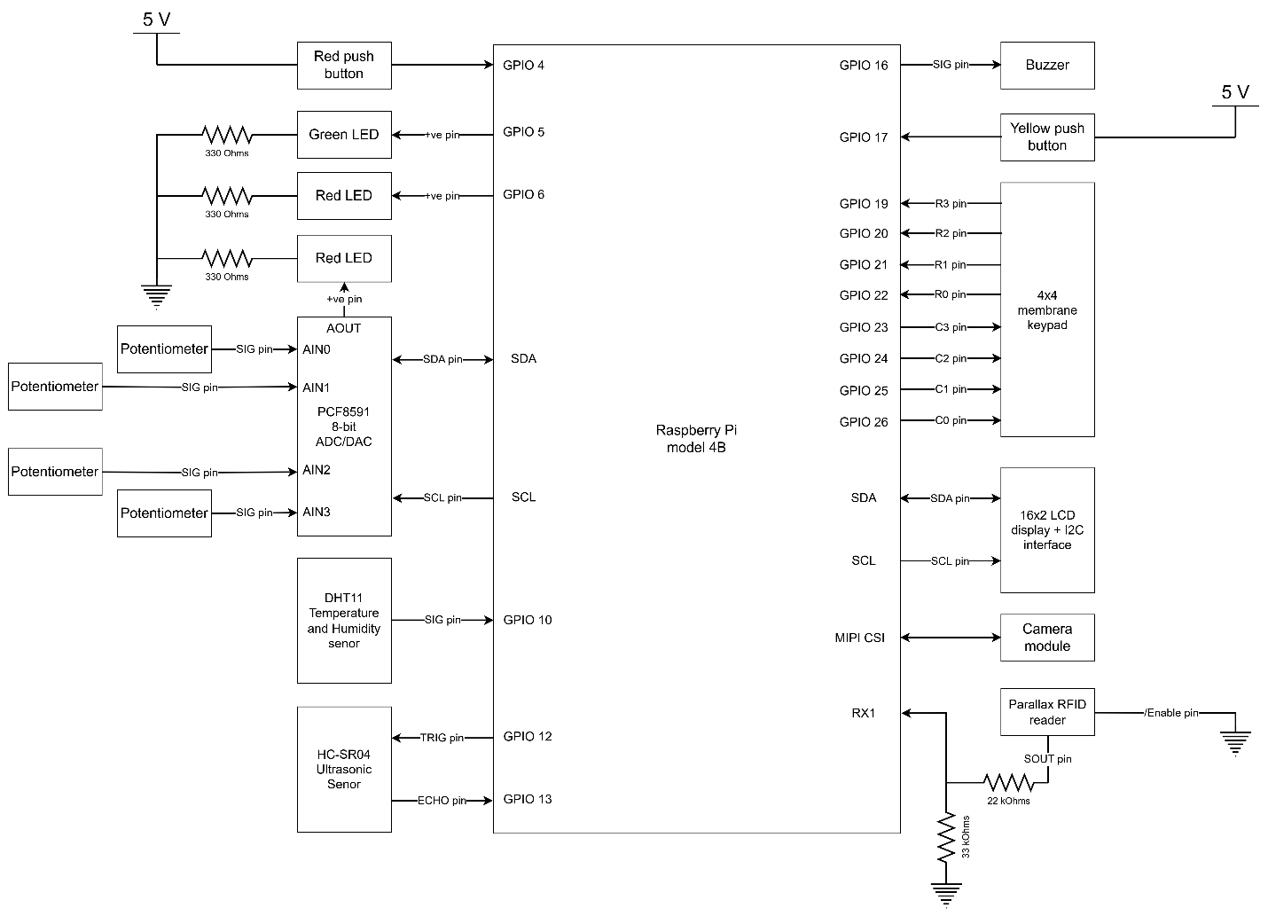

Figure – System interface diagram

Note: The power connections to the modules have been omitted to simplify the diagram. The PCF8591 and potentiometer modules were supplied with Vcc = 3.3V. DHT11, HC-SR04, Buzzer, LCD, and RFID modules all supplied with Vcc = 5V on the other hand.

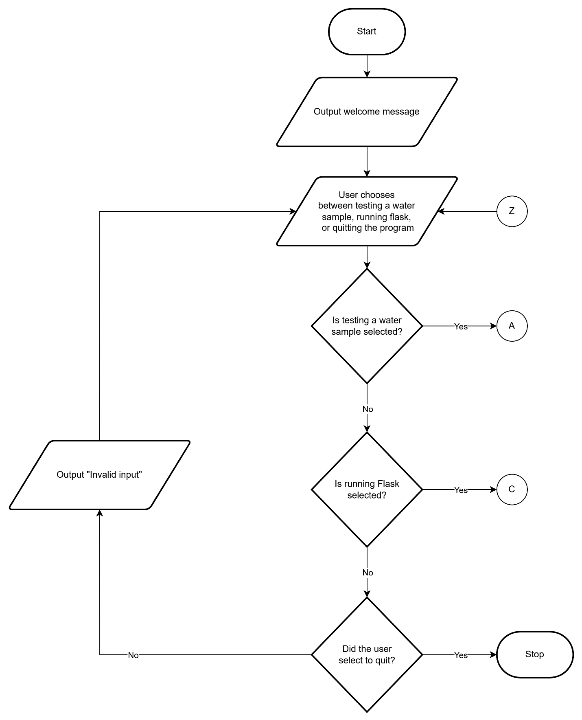

Figure – Flow chart 1 (Main)

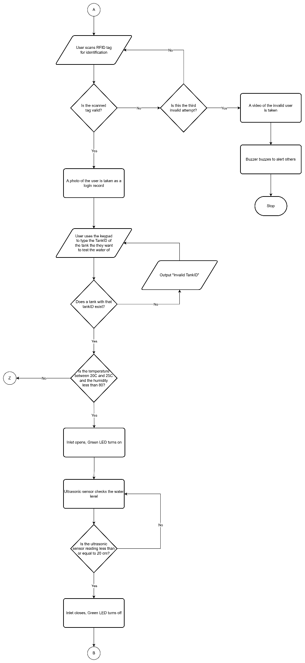

Figure - Flow chart 2.1 (Water quality testing part 1)

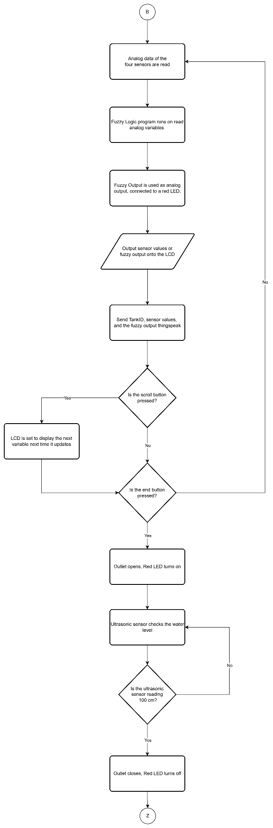

Figure - Flow chart 2.2 (Water quality testing part 2)

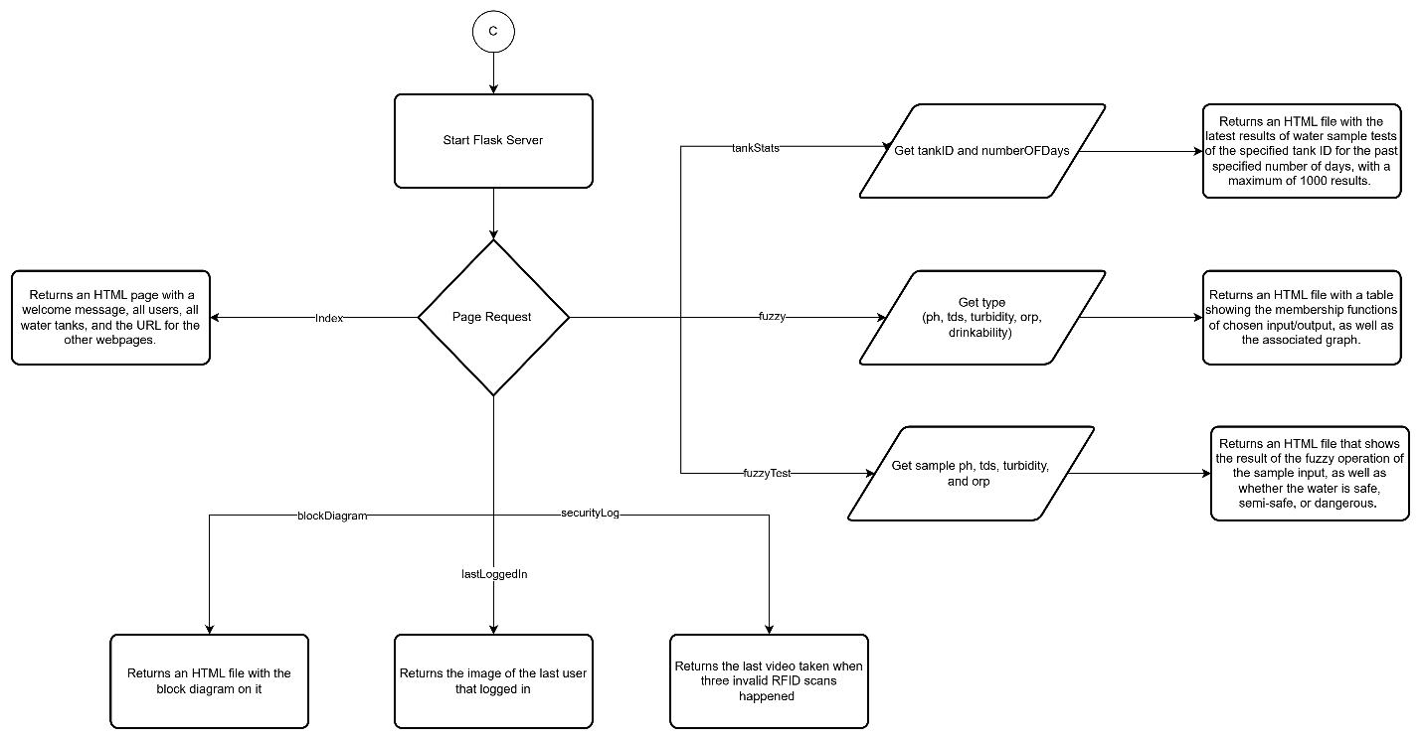

Figure - Flow chart 3 (Flask)

# Commented code

## myFuzzy.py

# Fuzzy system simulation through simplefied system - generated by GPT

# Simulation of pH input variable

def categorize_ph(ph):

if 0 <= ph < 6:

return "Acidic"

elif 6 <= ph <= 8:

return "Neutral"

elif 8 < ph <= 14:

return "Basic"

else:

raise ValueError("PH value out of range")

# Simulation of TDS input variable

def categorize_tds(tds):

if 0 <= tds < 100:

return "Stale"

elif 100 <= tds < 1000:

return "Normal"

elif 1000 <= tds <= 2000:

return "Salty"

else:

raise ValueError("TDS value out of range")

# Simulation of turbidity input variable

def categorize_turbidity(turbidity):

if 0 <= turbidity < 1.5:

return "Clear"

elif 1.5 <= turbidity <= 5:

return "Cloudy"

else:

raise ValueError("Turbidity value out of range")

# Simulation of ORP input variable

def categorize_orp(orp):

if -1500 <= orp < 200:

return "Unsuitable"

elif 200 <= orp <= 1500:

return "Suitable"

else:

raise ValueError("ORP value out of range")

# Function to run the "Fuzzy" system depending on the given inputs. Output will be the simulation of the drinkability output variable varying between 0-100

def runFuzzy(ph, tds, turbidity, orp):

PH = categorize_ph(ph)

TDS = categorize_tds(tds)

Turbidity = categorize_turbidity(turbidity)

ORP = categorize_orp(orp)

# Rule Set for 'Dangerous' outcome

if PH == 'Acidic':

if TDS in ['Stale', 'Normal', 'Salty']:

return 100 # Dangerous

elif PH == 'Basic':

if TDS in ['Stale', 'Normal', 'Salty']:

return 100 # Dangerous

# Rule Set for 'Semi-safe' and 'Safe' outcome

if PH == 'Neutral':

if TDS == 'Stale':

if ORP == 'Suitable':

if Turbidity == 'Clear':

return 0 # Safe

else: # Turbidity is Cloudy

return 50 # Semi-safe

else: # ORP is Unsuitable

return 50 # Semi-safe

elif TDS == 'Normal':

if ORP == 'Suitable':

if Turbidity == 'Clear':

return 0 # Safe

else: # Turbidity is Cloudy

return 50 # Semi-safe

else: # ORP is Unsuitable

return 50 # Semi-safe

elif TDS == 'Salty':

return 50 # Semi-safe

## Project.py

### RFID tags:

### 5300C80323 is is the clear card and is not valid

### 5300C8121A is is the card with a sticker and is not valid

### 010FB3B47B is is the disk shaped tag and is valid

### 5400653D3D is from scooter group and is valid

### 5300C82FB3 is from home security group and is valid

### 46003B3CD0 is from fire alarm group and is valid

# Imports

import RPi.GPIO as GPIO

import time

import LCD1602 as LCD

import keypadfunc as KP

import RFID

import PCF8591 as ADC

import dht as DHT

import urllib.request as URL

import requests

import myFuzzy

import os

from flask import Flask, render_template, send_file

from picamera import PiCamera

from datetime import datetime

# Global variables

END_BUTTON = 17 # Yellow button

SCROLL_BUTTON = 4 # Red button

LED_INLET = 5 # Green LED

LED_OUTLET = 6 # Red LED

BUZZER = 16

TRIG = 12

ECHO = 13

DHT_SENSOR = 10

PH_POT_CHANNEL = 0 # Red ADC wire

TDS_POT_CHANNEL = 1 # White ADC wire

TUR_POT_CHANNEL = 2 # Brown ADC wire

ORP_POT_CHANNEL = 3 # Yellow ADC wire

prompt = ""

mode = ""

tagRFID = ""

API_KEY = "Y0XB7TFU6Q637EPL"

CH_ID = 2324161

NumberOfReadings = 1000

tankIDs = ["123", "155", "139", "111"]

system = True

validRFIDs = [("010FB3B47B", "Ahmad Mansour"), ("5400653D3D", "Salman Siddiqui"), ("5300C82FB3", "Snapping Turtle"), ("46003B3CD0", "Goofy Stuff")]

endTest = False

# Order: pH, TDS, Turbidity, ORP (Fuzzy last one in reading and names)

readings = [0.0,0.0,0.0,0.0,0.0]

channels = [PH_POT_CHANNEL, TDS_POT_CHANNEL, TUR_POT_CHANNEL, ORP_POT_CHANNEL]

thresholds = [14, 2000, 5, 3000]

names = ["pH", "TDS", "Turbidity", "ORP", "Drinkability"]

LCDIndex = 4

# ADC initialization

ADC.setup(0x48)

# LCD initialization

LCD.init(0x27, 1)

# GPIO setup

GPIO.setwarnings(False)

GPIO.setmode(GPIO.BCM)

# I/O pin setup

GPIO.setup([END_BUTTON, SCROLL_BUTTON], GPIO.IN, pull_up_down=GPIO.PUD_DOWN)

GPIO.setup([ECHO], GPIO.IN)

GPIO.setup([LED_INLET, LED_OUTLET, BUZZER, TRIG], GPIO.OUT)

# Buzzer setup

buzz = GPIO.PWM(BUZZER, 0.1)

buzz.start(50)

# Flask configuration code with camera

mycamera = PiCamera()

mycamera.resolution = (640, 480) # Switching resolution to not fill the screen

myapp = Flask(__name__)

# Function to flush inputs

def flushInputs():

global tagRFID, modeKB, mode, prompt, endTest, LCDIndex

tagRFID = ""

modeKB = ""

mode = ""

prompt = ""

endTest = False

LCDIndex = 4

# Distance method definition and implementation

def distance():

GPIO.output(TRIG, GPIO.LOW)

time.sleep(0.000002)

GPIO.output(TRIG, 1)

time.sleep(0.00001)

GPIO.output(TRIG, 0)

while GPIO.input(ECHO) == 0:

dummy = 0

time1 = time.time()

while GPIO.input(ECHO) == 1:

dummy = 0

time2 = time.time()

duration = time2 - time1

return duration*1000000/58

# Function to display readings on LCD

def displayReading():

global readings, names, LCDIndex

LCD.clear()

LCD.write(0,0,names[LCDIndex])

LCD.write(0,1,"{:0.2f}".format(readings[LCDIndex]))

# Interrupt 1: Check if end button was pressed to end water sample testing

def stopTesting(self):

global mode, endTest

if (mode == "test"):

endTest = True

# Interrupt 2: Scrolls variables displayed on LCD screen when scroll button is pressed

def scrollLCD(self):

global LCDIndex

LCDIndex = (LCDIndex + 1)%5

# Interrupt events

GPIO.add_event_detect(END_BUTTON, GPIO.RISING, callback=stopTesting, bouncetime=500)

GPIO.add_event_detect(SCROLL_BUTTON, GPIO.RISING, callback=scrollLCD, bouncetime=500)

# ThingSpeak upload function

def sendToThing(tankID, pH, TDS, tur, ORP, fuzzyOut):

dummy = URL.urlopen("https://api.thingspeak.com/update?api_key={}&field1={}&field2={}&field3={}&field4={}&field5={}&field6={}".format(API_KEY, tankID, pH, TDS, tur, ORP, fuzzyOut))

# Function to get data from Thingspeak based on the amount of days and tank ID specified. Returns the data as a JSON object to be used in an HTML file

def getThingData(numOfdays, tankID):

global CH_ID

global API_KEY

global NumberOfReadings

URL = "https://api.thingspeak.com/channels/{}/feeds.json?days={}&results={}".format(CH_ID, numOfdays, NumberOfReadings)

headers = {

'User-Agent': 'PostmanRuntime/7.34.0',

'Connection': 'keep-alive'

}

response = requests.get(URL, headers=headers)

data = response.json().get("feeds", [])

data = [entry for entry in data if entry['field1'] == str(tankID)]

return data

# Function to take photo

def takePhoto(ID, name):

timestamp = datetime.now().isoformat()

mycamera.start_preview()

mycamera.annotate_text = "User {} with ID {} logged in at {}".format(name, ID, timestamp)

time.sleep(2)

mycamera.capture("/home/pi/Desktop/F23/Project/image.jpg")

mycamera.stop_preview()

# Function to take short video

def takeVideo():

timestamp = datetime.now().isoformat()

mycamera.annotate_text = "Security breach - Time: {}".format(timestamp)

mycamera.start_recording("/home/pi/Desktop/F23/Project/video.h264")

time.sleep(5)

mycamera.stop_recording()

# Function to sound buzzer alarm

def runAlarm():

global buzz

for i in range(10):

buzz.ChangeFrequency(2800)

time.sleep(0.5)

buzz.ChangeFrequency(2500)

time.sleep(0.5)

buzz.ChangeFrequency(0.1)

# Function to authorize user before allowing them to test water sample

def authorizeUser():

global tagRFID, validRFIDs, RFID

count = 0

while (count < 3):

print("Scan your authorized user tag on the RFID scanner")

time.sleep(2)

while (not RFID.readRFID()): dummy = 0

tagRFID = RFID.readRFID()

for ID, name in validRFIDs:

if ID == tagRFID:

print("User {} authorized. Welcome {}".format(ID, name))

takePhoto(ID, name) # Triggered when someone successfully logs in. Takes photo of authorized user for record

return True

count += 1

print("Invalid tag... You have {} tries left.".format(3-count))

# Triggered when someone attempts accessing system unsuccessfully 3 times in a row. Takes short video then sounds buzzer alarm

takeVideo()

runAlarm()

return False

# Function used to choose a valid tank ID using keypad, returns chosen tank ID

def chooseTank():

global tankIDs

key, keyS = ("","")

while True:

inputID = ""

print("Enter the tank ID to be sampled (press # to confirm): ", end = "")

key, keyS = KP.keypad()

key = str(key)

while (key != "#"):

inputID = inputID + key

print(key, end = "")

time.sleep(0.25)

key, keyS = KP.keypad()

key = str(key)

time.sleep(0.2)

print("")

if inputID in tankIDs:

print("Tank {} chosen successfully".format(inputID))

return inputID

else:

print("Invalid tank ID...")

# Function used to read ADC of passed channel and convert to meaningful reading

def readADC(chn, thresh):

global ORP_POT_CHANNEL

temp = ADC.read(chn)

temp = (temp/256.0) * float(thresh)

# ORP can vary between -1500 to 1500 so if we are reading from ORP we set threshold as 3000 and then subtract 1500

if chn == ORP_POT_CHANNEL: temp -= 1500

return temp

# Function used to write to ADC using passed value and threshold to be converted to ADC code

def writeADC(val, thresh):

if val > thresh: val = thresh

temp = float(val)/float(thresh) * 255

ADC.write(temp)

# Function used to test water sample after authorization and a tank was chosen

def testWater(tankID):

global endTest, readings, channels, thresholds, names, LCDIndex

# Step 1: Check if humidity and temperature of test tank is suitable

abort = False

humidity, temperature = DHT.getValues(DHT_SENSOR)

if humidity > 80: # humidity limits are subject to change

print("Humidity of the test tank is not suitable.")

abort = True

if temperature > 25 or temperature < 20:

print("Temperature of the test tank is not suitable.")

abort = True

if abort:

print("Aborting test session...")

return

print("Test tank conditions | Humidity:{}%, Temperature: {}C".format(humidity, temperature))

# Step 2: Open test tank inlet (inlet LED) and wait until test tank full (ultrasonic detects < 20cm)

print("Opening test tank inlet...")

GPIO.output(LED_INLET, GPIO.HIGH)

time.sleep(1)

dis = distance()

if dis > 100: dis = 100

while dis > 20:

print("Water level: {:0.2f} cm".format(100-dis))

time.sleep(2)

dis = distance()

if dis > 100: dis = 100

# Step 3: Close inlet

print("Test tank reached adequate water level. Closing test tank inlet...")

GPIO.output(LED_INLET, GPIO.LOW)

time.sleep(1)

## Until end button is pressed...

while not endTest:

# Step 4: Read ADC and store in variables

for i in range (4):

readings[i] = readADC(channels[i], thresholds[i])

# Step 5: Run fuzzy logic and get output

readings[4] = myFuzzy.runFuzzy(readings[0], readings[1], readings[2], readings[3])

# Step 6: Adjust brightness of analog out LED

writeADC(readings[4] + 15, 100)

# Step 7: Display readings/fuzzy on LCD

displayReading()

# Step 8: Send tank ID, sensor readings and fuzzy output to thingspeak

sendToThing(tankID, readings[0], readings[1], readings[2], readings[3], readings[4])

time.sleep(0.1)

print("End button pressed. Testing session terminated.")

LCD.clear()

writeADC(0,1)

# Step 9: Open outlet (outlet LED) and wait until test tank empty (ultrasonic detects around 100cm)

print("Opening test tank outlet...")

GPIO.output(LED_OUTLET, GPIO.HIGH)

time.sleep(1)

dis = distance()

if dis > 100: dis = 100

while dis < 100:

print("Water level: {:0.2f} cm".format(100-dis))

time.sleep(2)

dis = distance()

if dis > 100: dis = 100

# Step 10: Close outlet

print("Test tank drained. Closing test tank outlet...")

GPIO.output(LED_OUTLET, GPIO.LOW)

time.sleep(1)

@myapp.route("/") # index page

def index():

return render_template("index.html", validRFIDs=validRFIDs, tankIDs=tankIDs)

@myapp.route("/lastLoggedIn") # Static page to show picture and name of last login

def lastLogin():

return send_file("/home/pi/Desktop/F23/Project/image.jpg", mimetype = "image/jpeg")

@myapp.route("/blockDiagram") # Static page to show block diagram ;)

def blockDiagram():

return render_template("block_diagram.html")

@myapp.route("/ph") # Static page to show picture the pH input graph

def ph():

return send_file("/home/pi/Desktop/F23/Project/templates/FuzzyHTML_files/lvtemporary_394949.jpg", mimetype = "image/jpeg")

@myapp.route("/tds") # Static page to show picture the TDS input graph

def tds():

return send_file("/home/pi/Desktop/F23/Project/templates/FuzzyHTML_files/lvtemporary_42731.jpg", mimetype = "image/jpeg")

@myapp.route("/turbidity") # Static page to show picture the Turbidity input graph

def turbidity():

return send_file("/home/pi/Desktop/F23/Project/templates/FuzzyHTML_files/lvtemporary_192897.jpg", mimetype = "image/jpeg")

@myapp.route("/orp") # Static page to show picture the orp input graph

def orp():

return send_file("/home/pi/Desktop/F23/Project/templates/FuzzyHTML_files/lvtemporary_119800.jpg", mimetype = "image/jpeg")

@myapp.route("/drinkability") # Static page to show picture the drinkability output graph

def drinkability():

return send_file("/home/pi/Desktop/F23/Project/templates/FuzzyHTML_files/lvtemporary_774252.jpg", mimetype = "image/jpeg")

@myapp.route("/securityLog") # Static page to download last taken video of security breach

def securityLog():

return send_file("/home/pi/Desktop/F23/Project/video.h264", mimetype = "video/h.264")

@myapp.route("/tankStats/<id>/<numOfDays>") # Dynamic page to show history of water test based on tank ID

def tankStats(id, numOfDays):

print(getThingData(numOfDays, id))

return render_template("tank_stats.html", data=getThingData(numOfDays, id), id = id, numOfDays = numOfDays)

@myapp.route("/fuzzy/<type>") # Dynamic page to show input/output fuzzy membership function graphs

def showFuzzy(type):

if (type.lower() == "ph"): return render_template("ph.html")

elif (type.lower() == "tds"): return render_template("tds.html")

elif (type.lower() == "turbidity"): return render_template("turbidity.html")

elif (type.lower() == "orp"): return render_template("orp.html")

elif (type.lower() == "drinkability"): return render_template("drinkability.html")

else: return "Invalid input..."

@myapp.route("/fuzzyTest/<ph>/<tds>/<turbidity>/<orp>") # Dynamic page to test fuzzy system by inputting values

def testFuzzy(ph, tds, turbidity, orp):

fuzzy_output = myFuzzy.runFuzzy(float(ph), float(tds), float(turbidity), float(orp))

if fuzzy_output < 33: drinkability = "Safe"

elif fuzzy_output > 66: drinkability = "Dangerous"

else: drinkability = "Semi-safe"

return render_template("fuzzy_test_result.html", ph=ph, tds=tds, turbidity=turbidity, orp=orp, fuzzy_output=fuzzy_output, drinkability=drinkability)

# Function to run flask if chosen

def runFlask():

if __name__ == "__main__":

myapp.run(host = "0.0.0.0", port = 5020)

# Welcome message

print("Welcome to the smart water quality monitoring system.\n" +

"This system allows you to run a water quality test on any of the available water tanks.\n" +

"The system measures pH, total dissolved solids (TDS), turbidity, and the oxidation reduction potential (ORP) of the water sampled from the chosen tank.\n" +

"Through the use of fuzzy logic, the drinkability of the sampled water will be assessed.\n")

# "main"

while system:

flushInputs()

prompt = input("To run the flask server, type F.\n" +

"To test a water sample, type T.\n" +

"To quit, type Q.\n" +

"Type your choice: ").lower()

if (prompt == "f"):

mode = "flask"

runFlask()

elif (prompt == "t"):

mode = "authorize"

system = authorizeUser()

if (system):

mode = "tank"

tank = chooseTank()

mode = "test"

testWater(tank)

elif (prompt == "q"):

mode = "quit"

system = False

print("Thank you for using the system. System shutting down...")

else:

print("Invalid input...")

# **System photo**

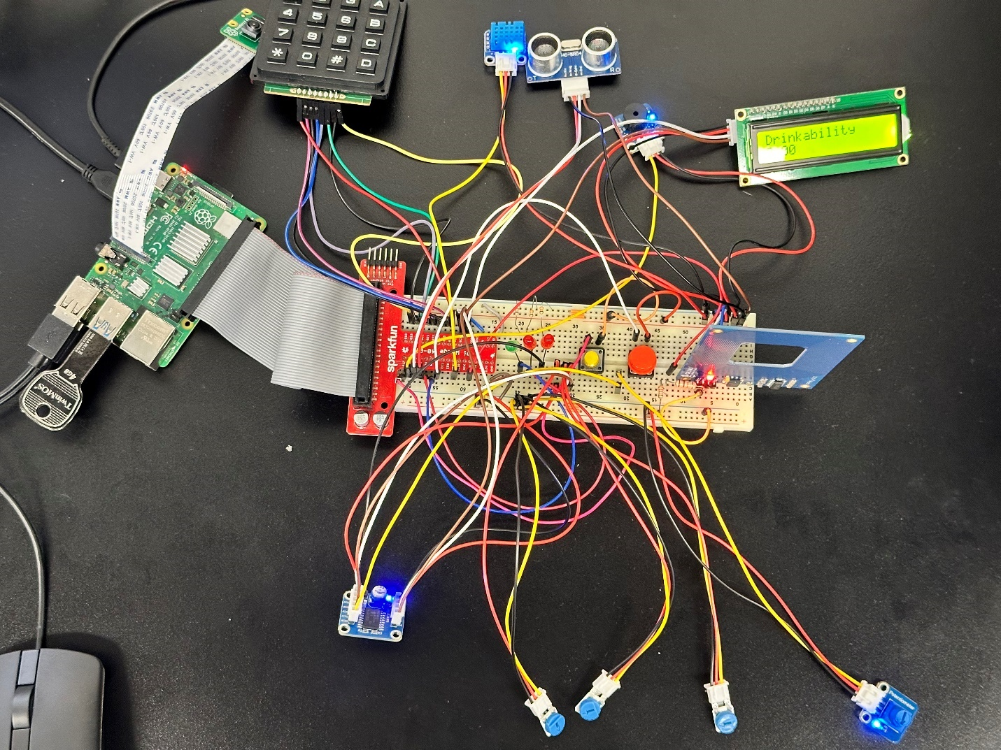

Figure - Physical system photo (top view)

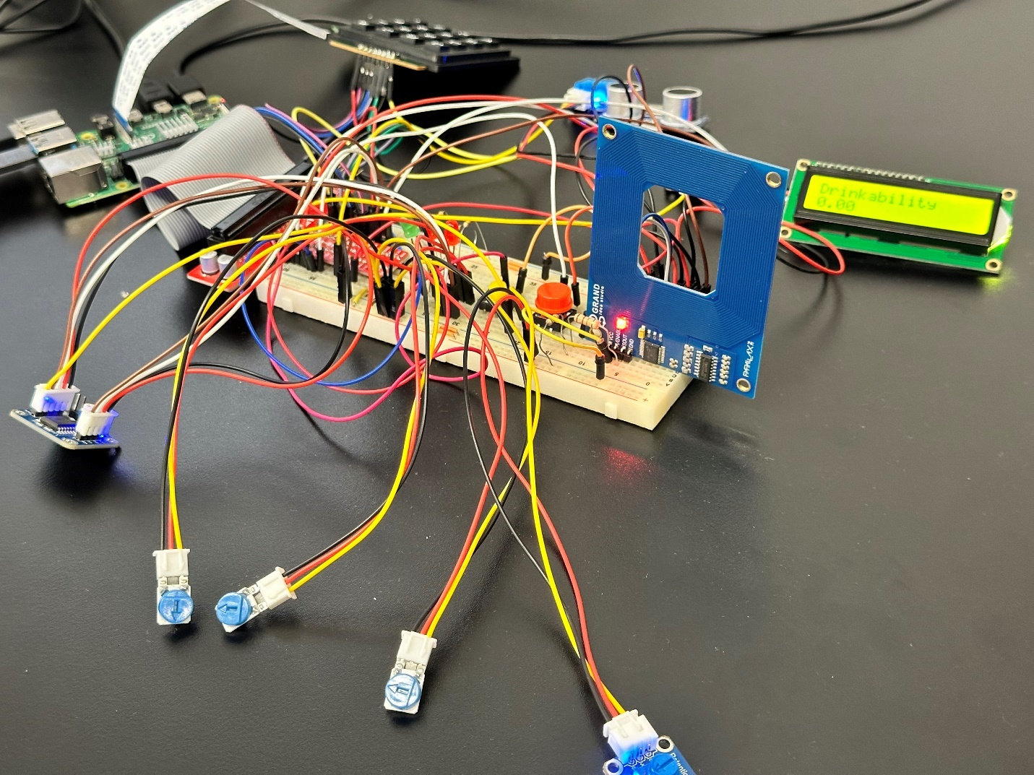

Figure - Physical system photo (side view)

# Execution scenarios

When the system starts up, a welcome message is displayed and the user is propmted with choosing between Flask mode, Test mode, or quit:

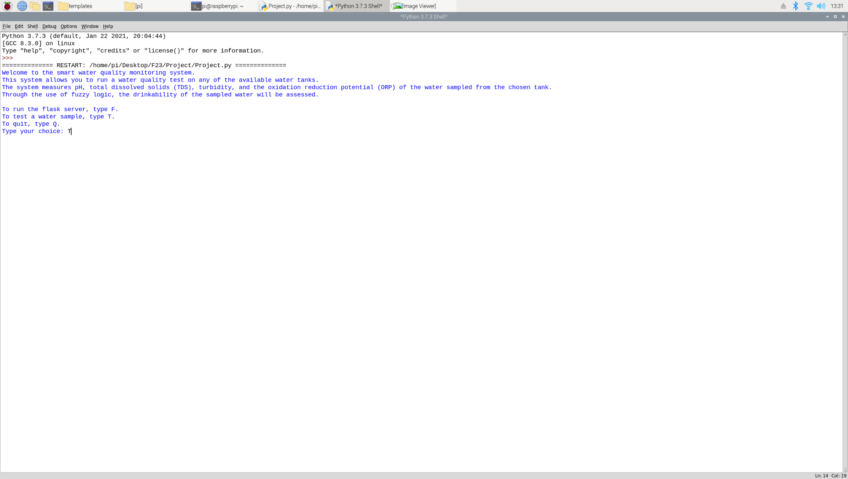

Figure - Welcome message and choice

If the user chooses test mode, they will be asked to validate themselves by scanning an authorized RFID card. If an invalid card is scanned thrice, a short video will be taken, the buzzer will sound an alarm, and the system will turn off. The last taken video can be downloaded from the “/securityLog” Flask static route:

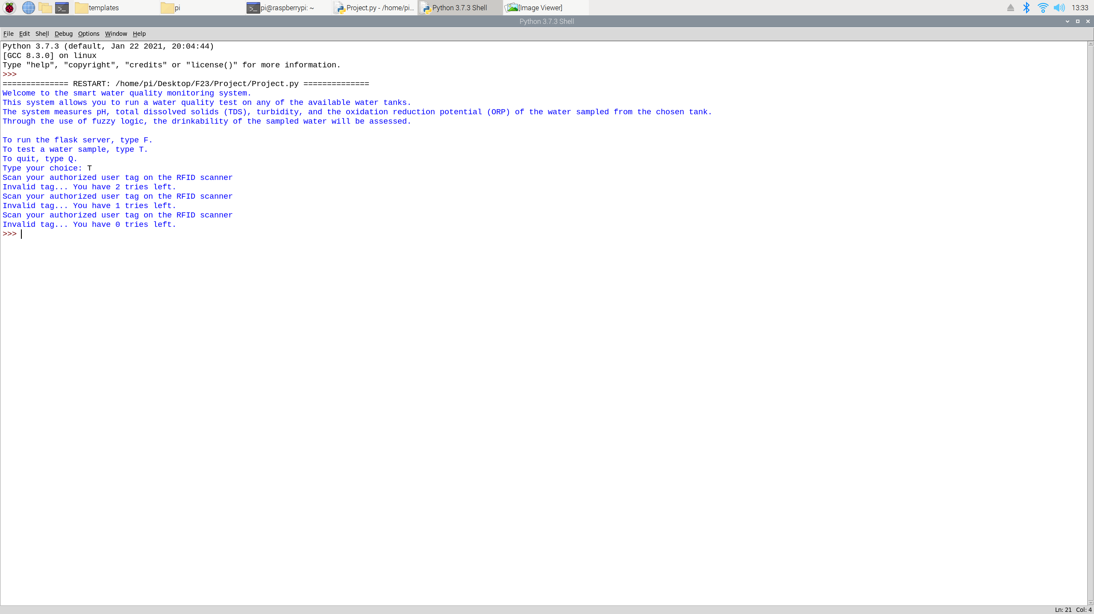

Figure - Unauthorized RFID scenario

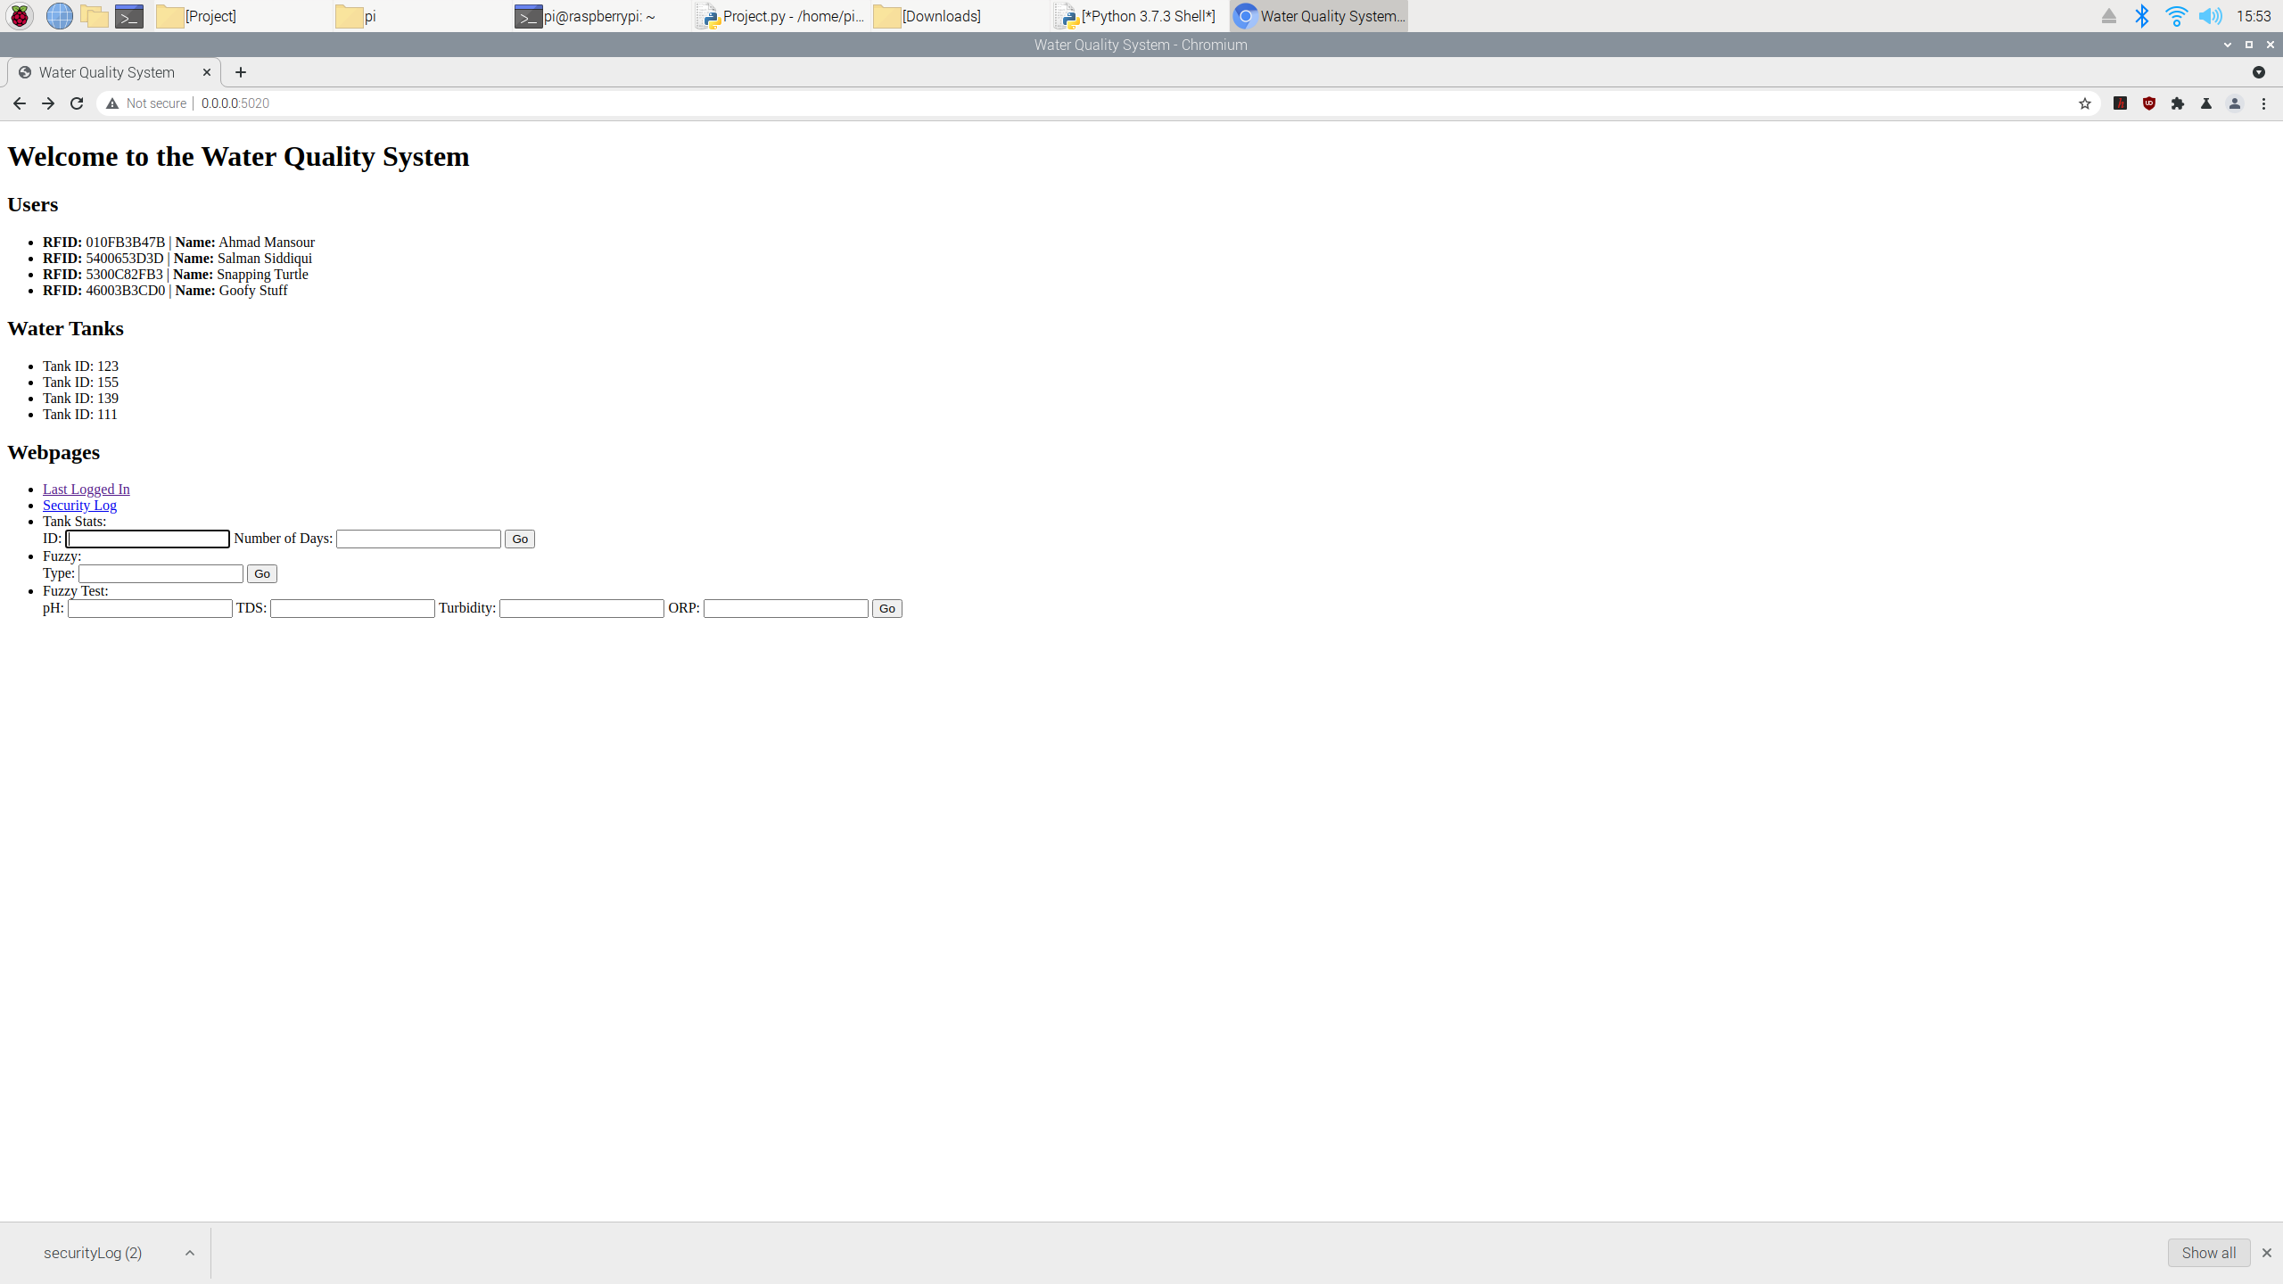

Figure - Downloading last taken video from Flask

If the user scans a valid RFID, a welcome message with the user’s name and RFID tag will be displayed. Additionally, the camera preview will open, and a photo will be taken. The photo of the last logged in user can be viewed from the “/lastLoggedIn” Flask static route:

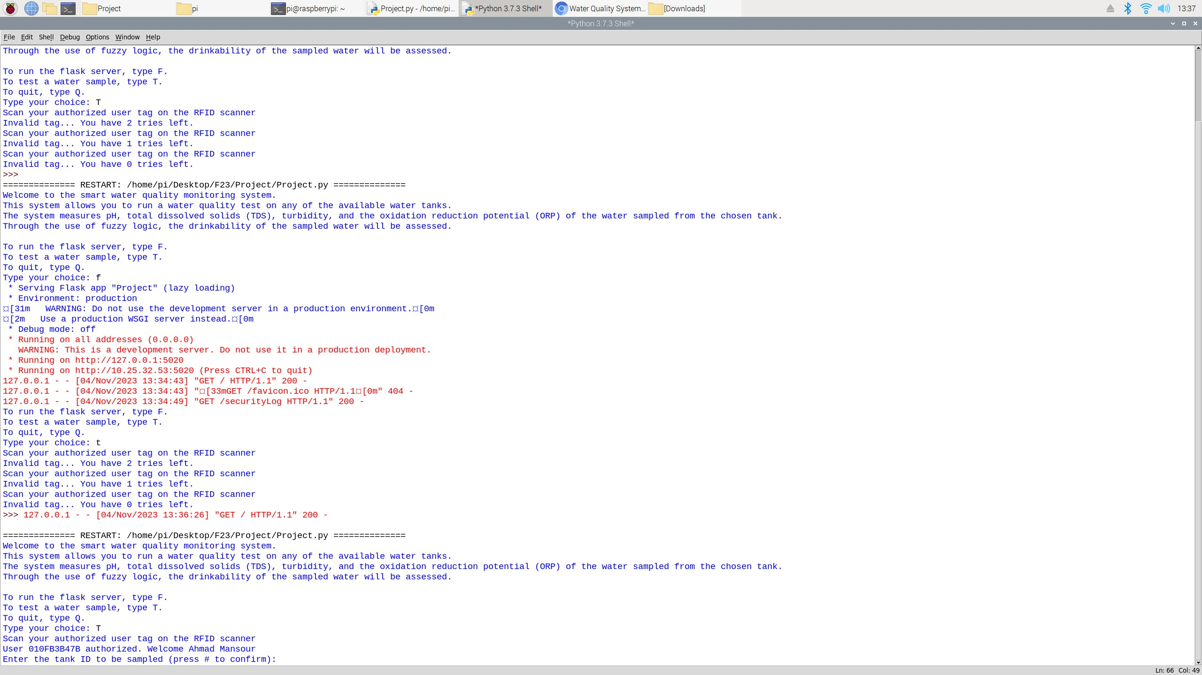

Figure - Authorized RFID scenario

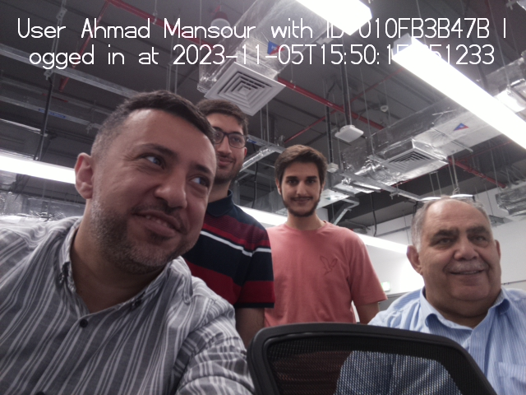

Figure - Last logged in photo preview through Flask

After authorized login, the user must choose a tank that they would like to run a water test on. This is done by inputting the tank ID using the keypad and pressing ‘#’ to confirm the entry. If the tank ID is invalid, the user is prompted to input the tank ID again. After inputting a proper tank ID, the system checks if the test tank’s humidity and temperature are suitable for testing. If they one of them are unsuitable, the system informs the user and exits to the main menu:

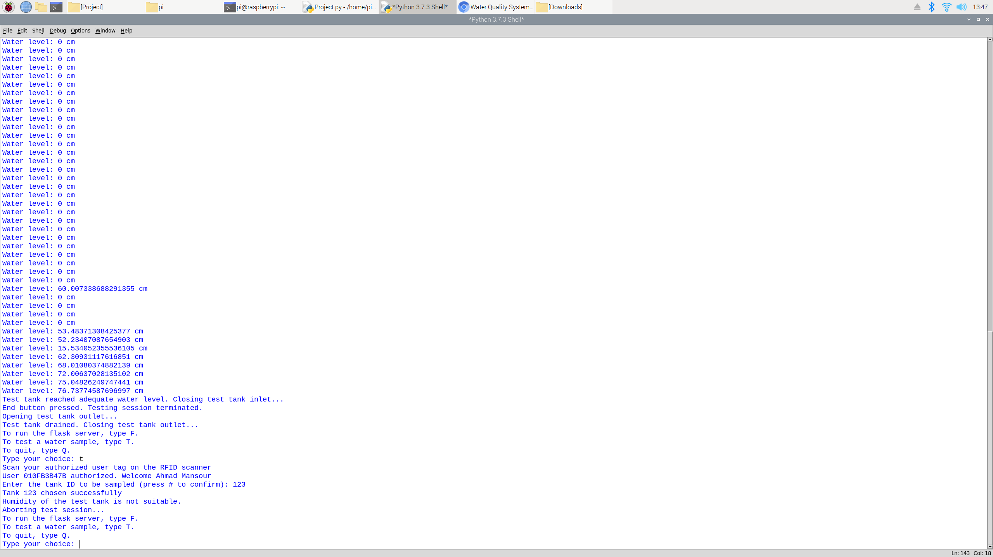

Figure - Unsuitable test tank conditions scenario

If a tank is chosen and the test tank conditions are suitable, the test tank’s humidity and temperature is displayed, and the test tank’s inlet is opened (simulated through the green LED):

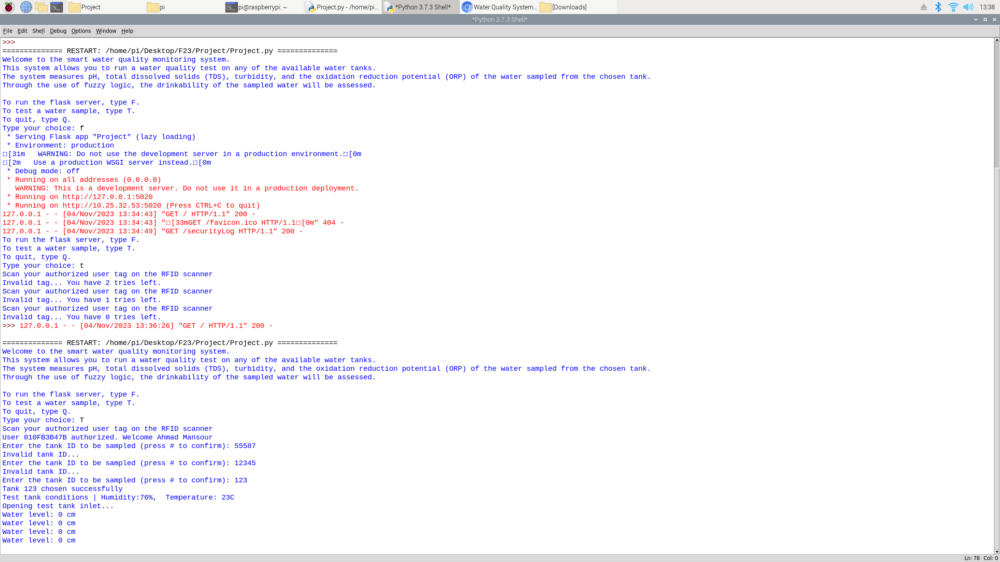

Figure - Suitable test tank conditions scenario

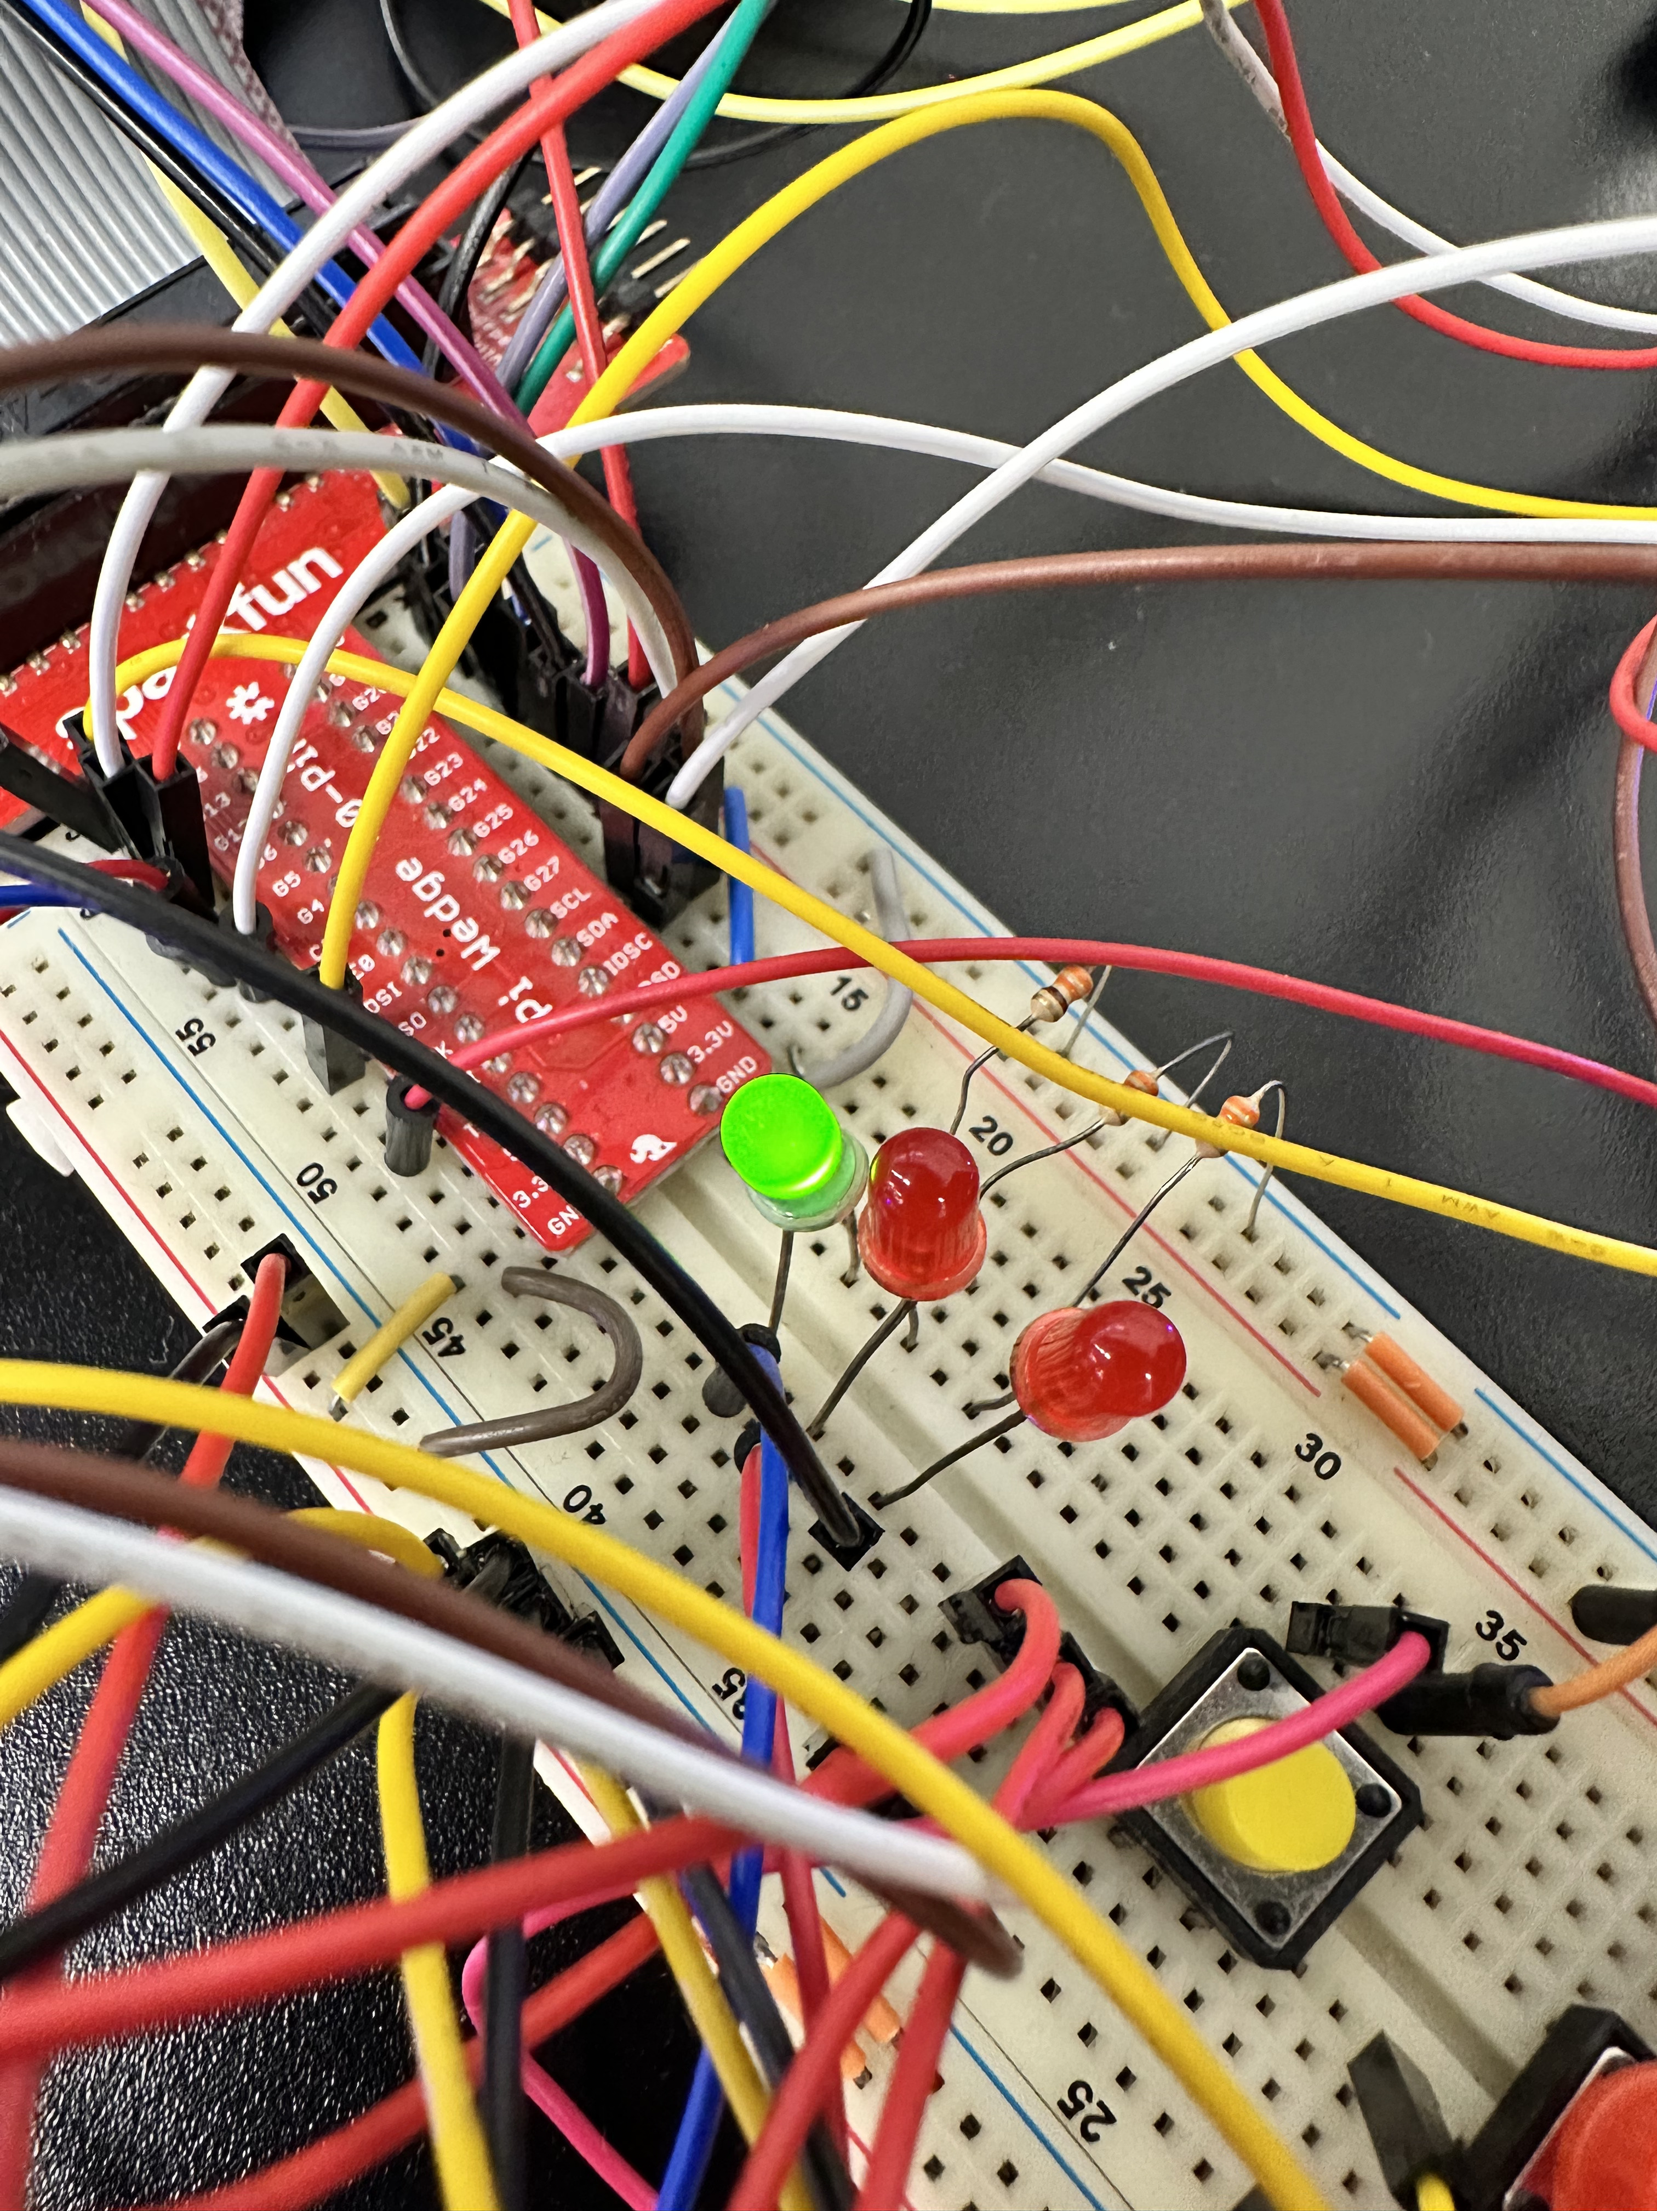

Figure - Inlet LED on

The inlet will stay on until adequate water level is achieved in the test tank. The water level is observed through the ultrasonic sensor and printed in the terminal. Once the water level reaches 80 cm, the inlet is closed:

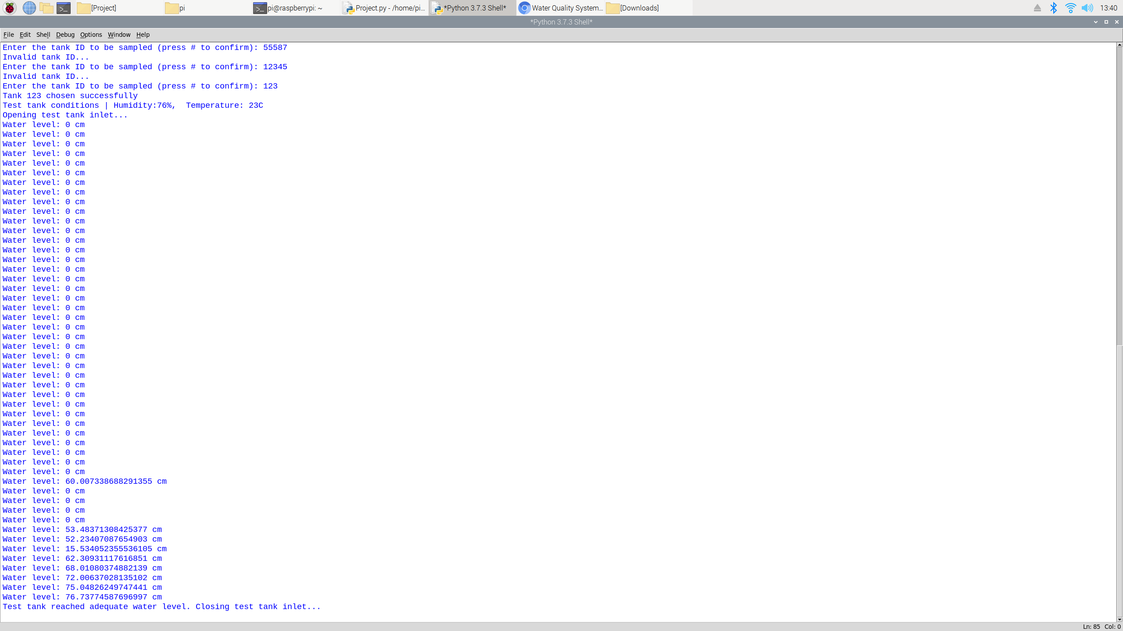

Figure - Water level check when inlet is open

Once the inlet is closed, the water quality testing begins. Throughout testing, pH, total dissolved solids (TDS), turbidity, and oxidation reduction potential (ORP) readings will be measured through the respective sensors (simulated through potentiometers). The read measurements are then used to calculate the drinkability, which is the fuzzy output of the system. The sensor readings and fuzzy output can be viewed through the LCD, where the user presses the scroll button to move between the different values. In addition, the measured sensor readings and fuzzy output alongside the tank ID from which the water is being tested is sent to the Thingspeak channel:

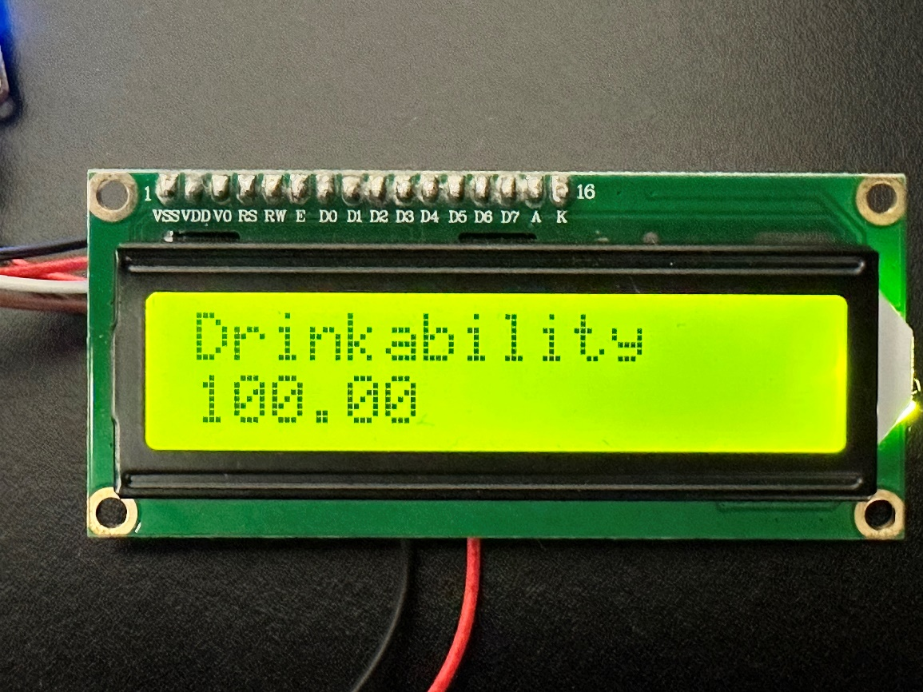

Figure - Fuzzy output on LCD (low pH so ‘Dangerous’ output)

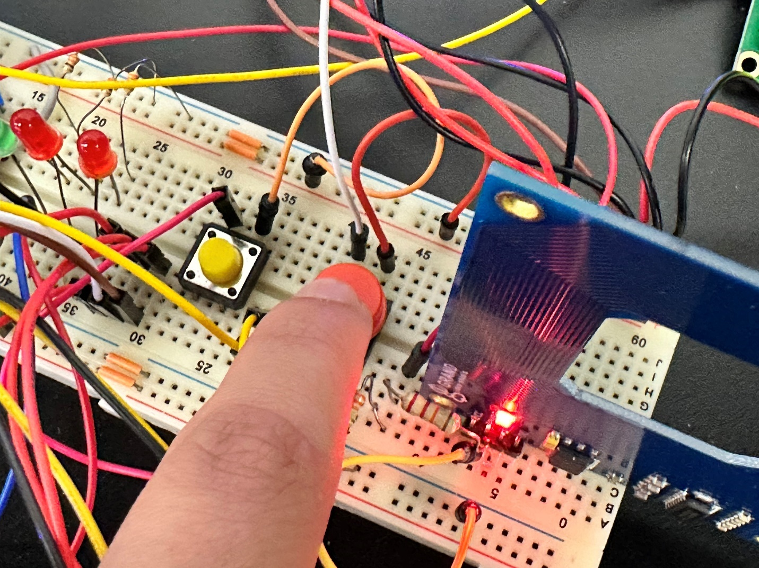

Figure - Pressing scroll button to display next reading on LCD

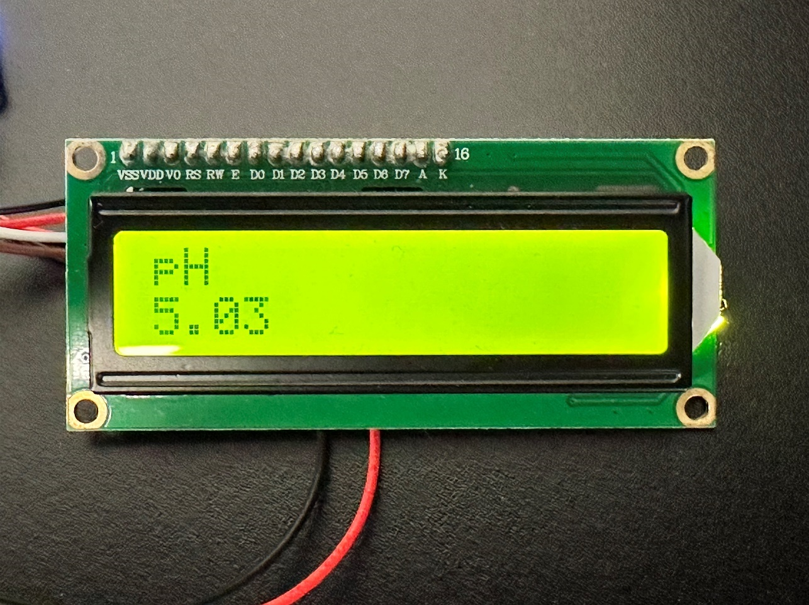

Figure - pH reading on LCD (acidic)

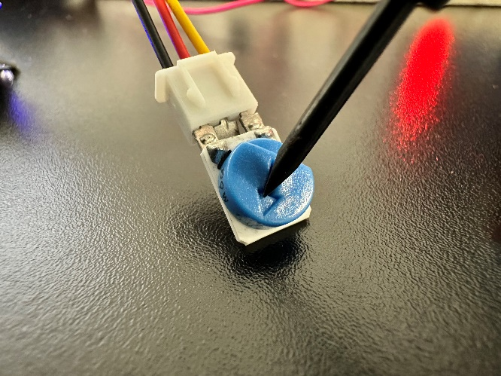

Figure - Changing pH value through associated potentiometer

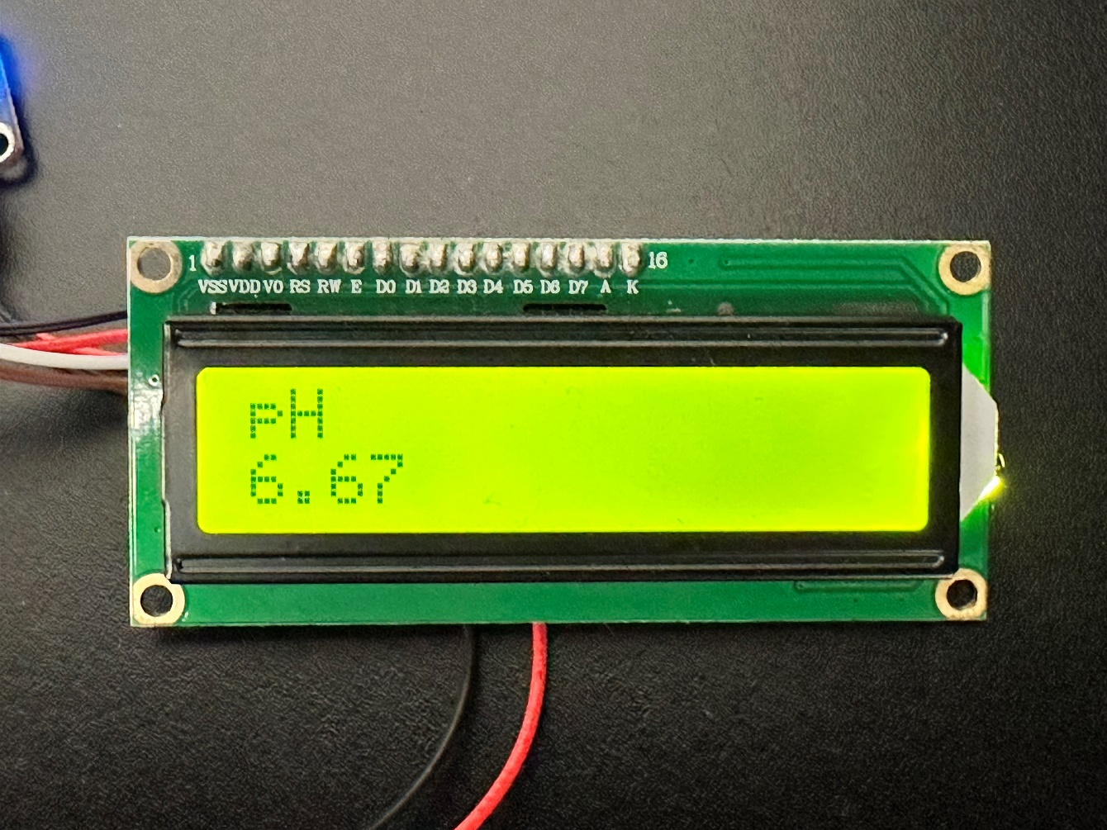

Figure - pH reading on LCD after adjustment (neutral)

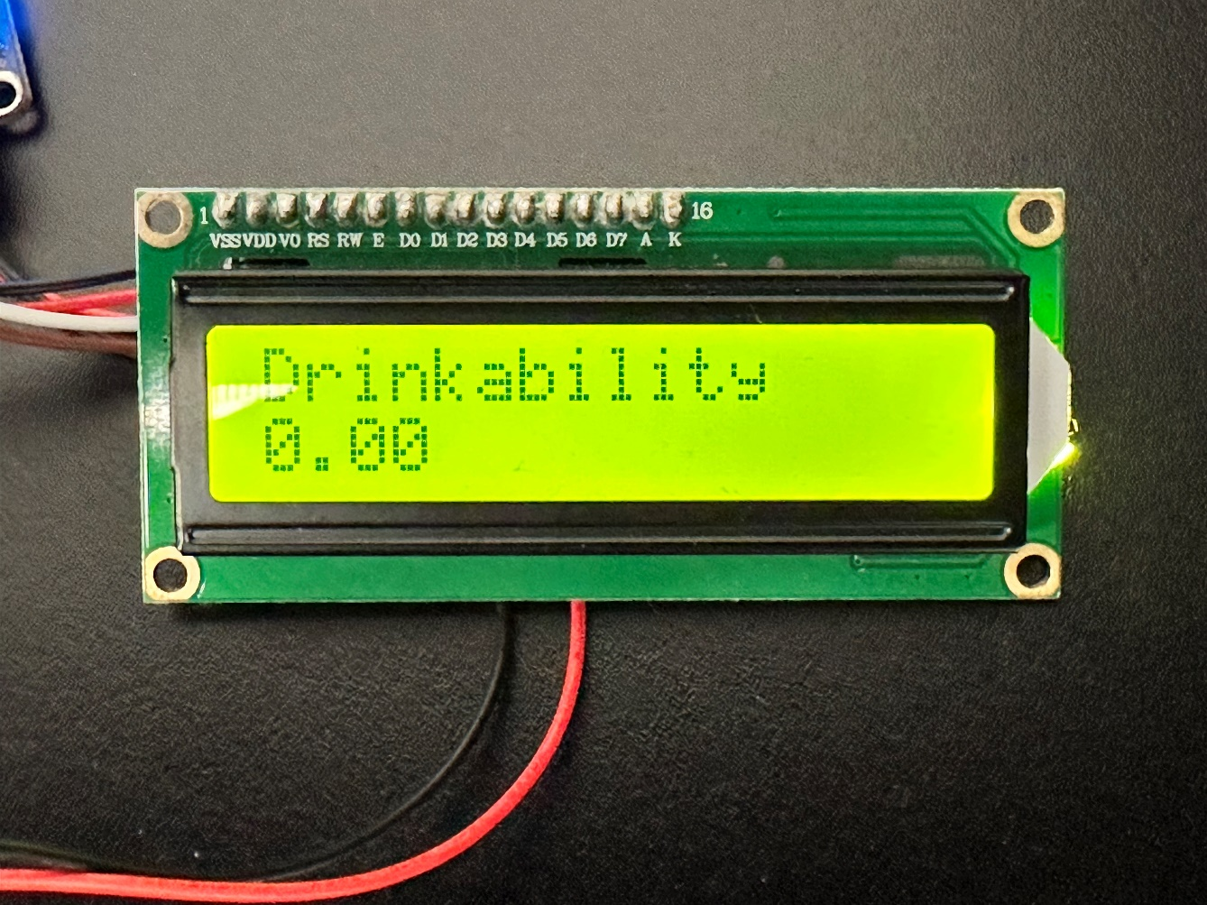

Figure - Fuzzy output on LCD after adjustment (neutral pH so ‘Safe’ output)

While testing, an LED also represents the fuzzy output through its brightness where off is ‘Safe’, dim is ‘Semi-safe’, and bright is ‘Dangerous’:

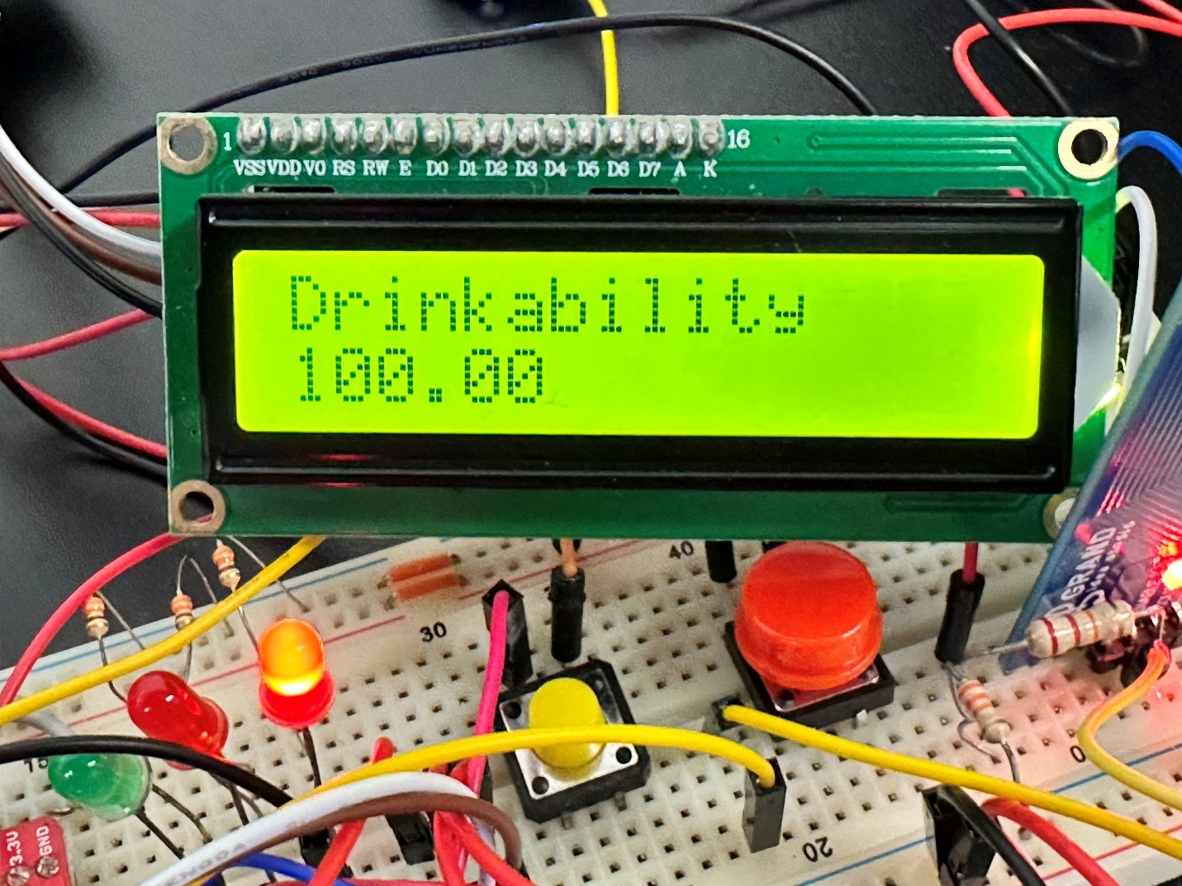

Figure - Bright LED when 'Dangerous'

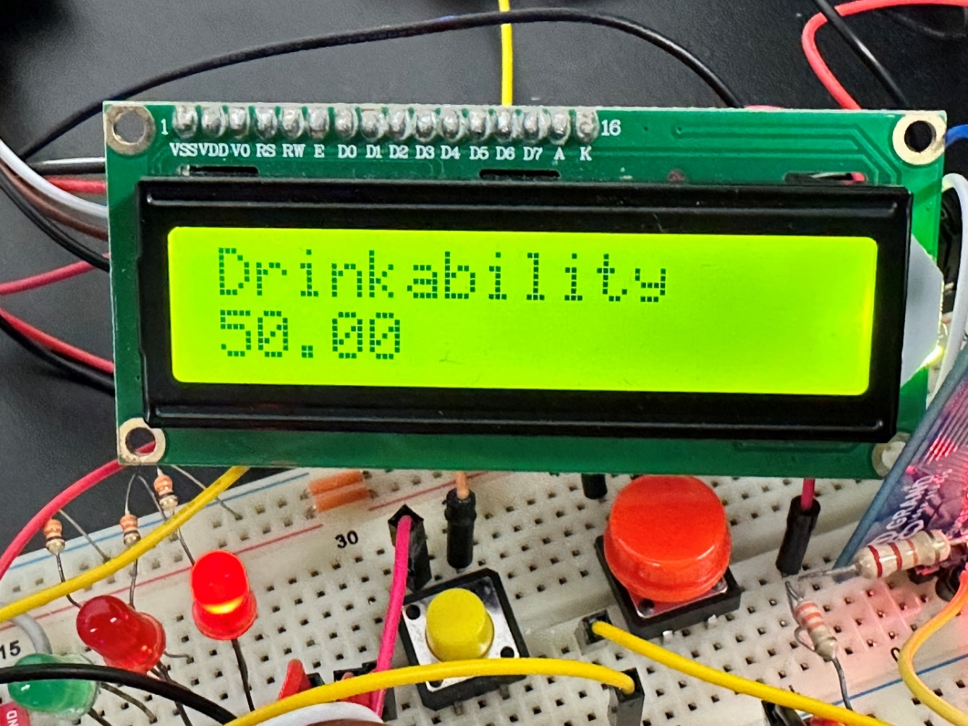

Figure - Dim LED when 'Semi-safe'

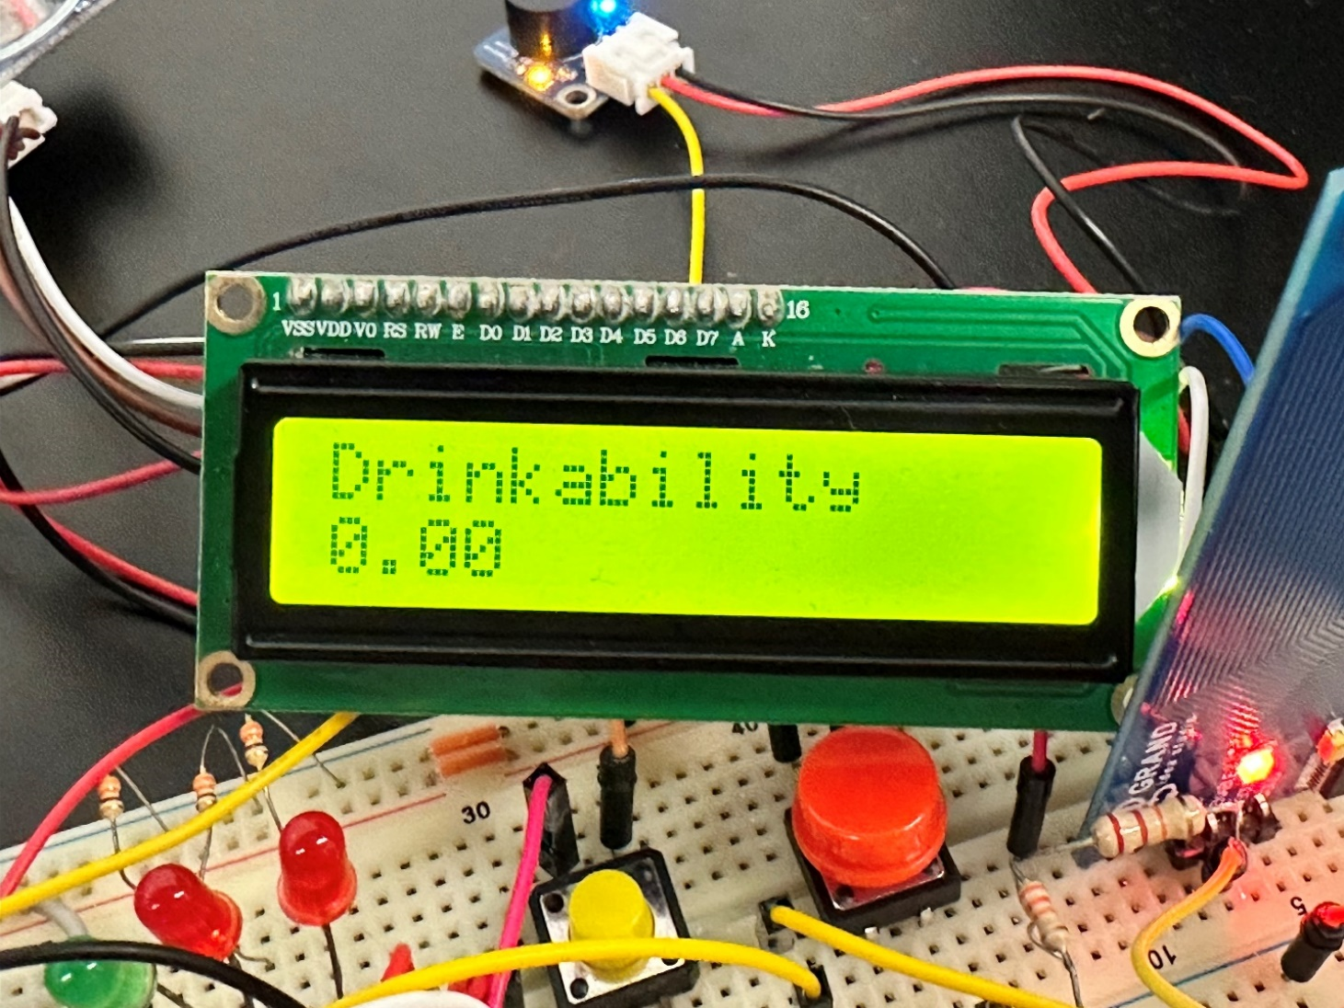

Figure - Off LED when 'Safe'

When the user is done testing, they can press the end button which will stop testing and open the outlet of the test tank (simulated through the red LED) to drain it. The outlet will stay on until all the water drains out of the tank (ie: water level reaches 0 cm):

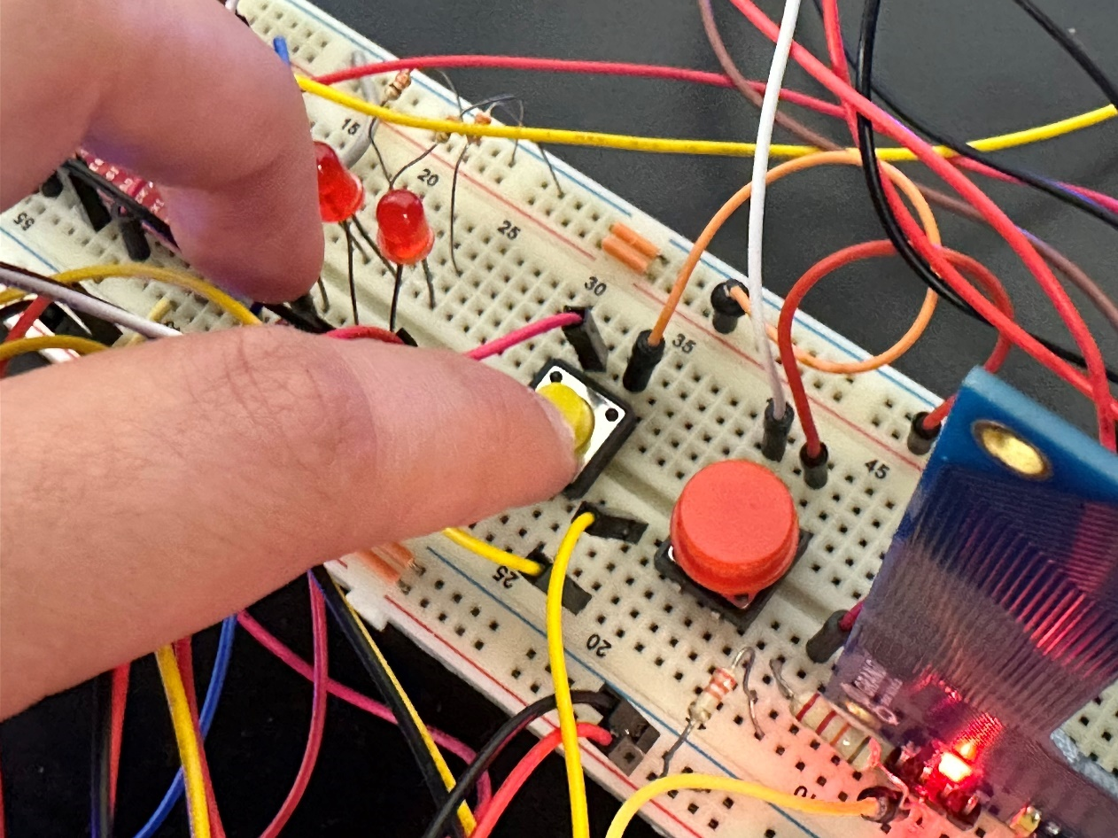

Figure - Pressing end button to stop testing

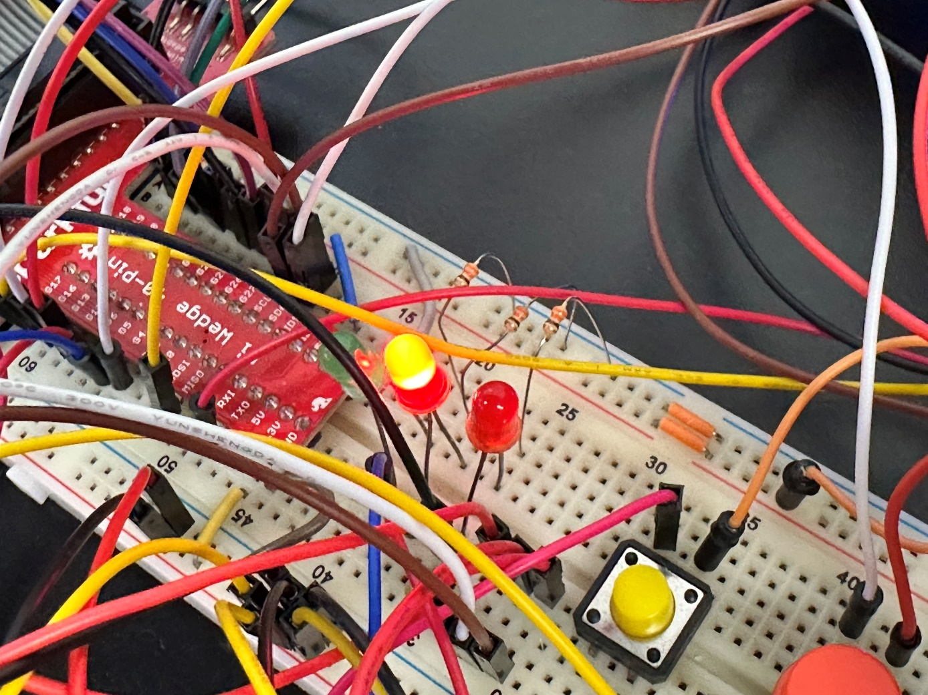

Figure - Outlet LED on

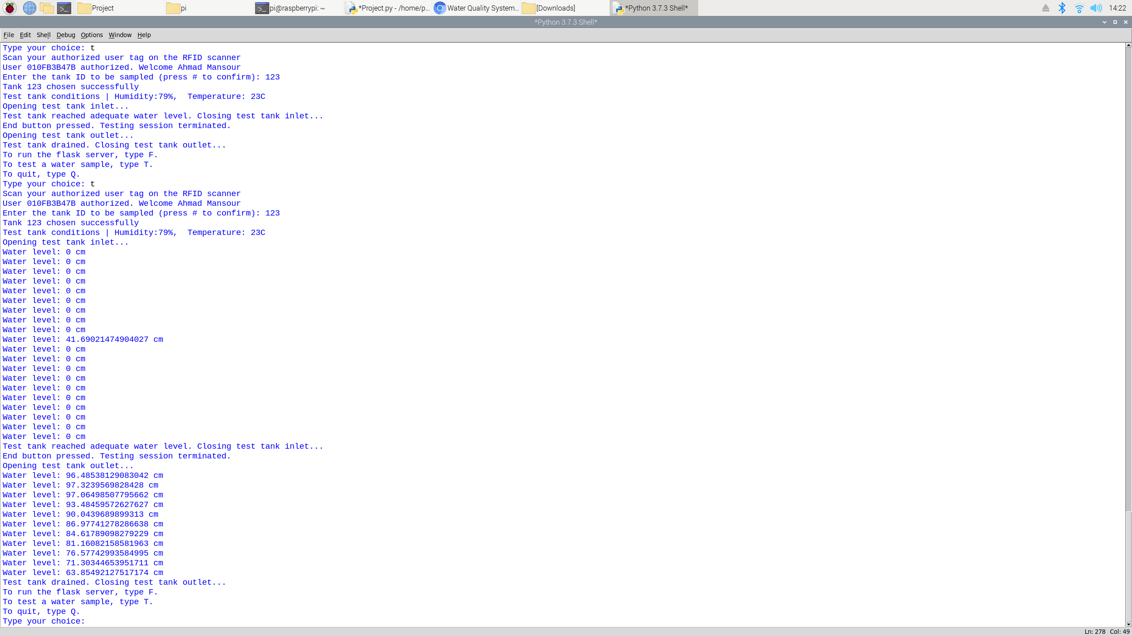

Figure - Water level check when outlet is open

In flask mode, the user can access all static and dynamic routes from the index route. In the index route, registered users, valid tank IDs, and links to other routes are presented:

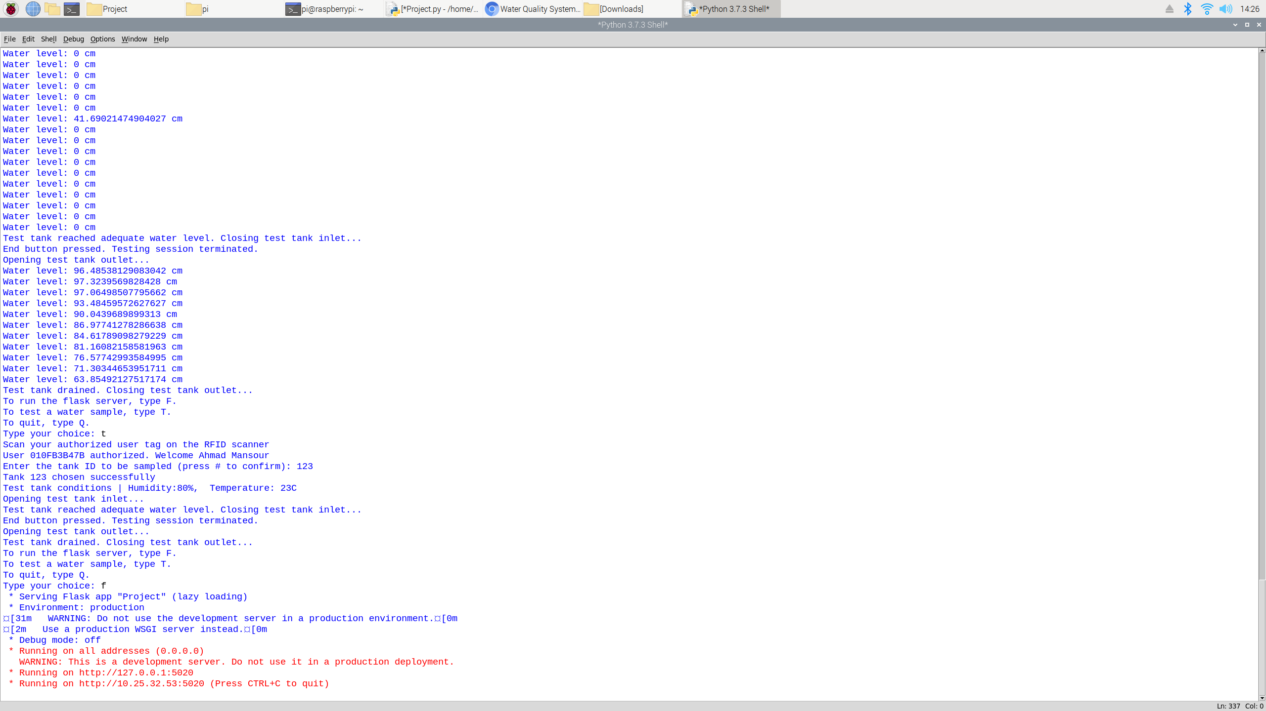

Figure - Choosing flask (terminal view)

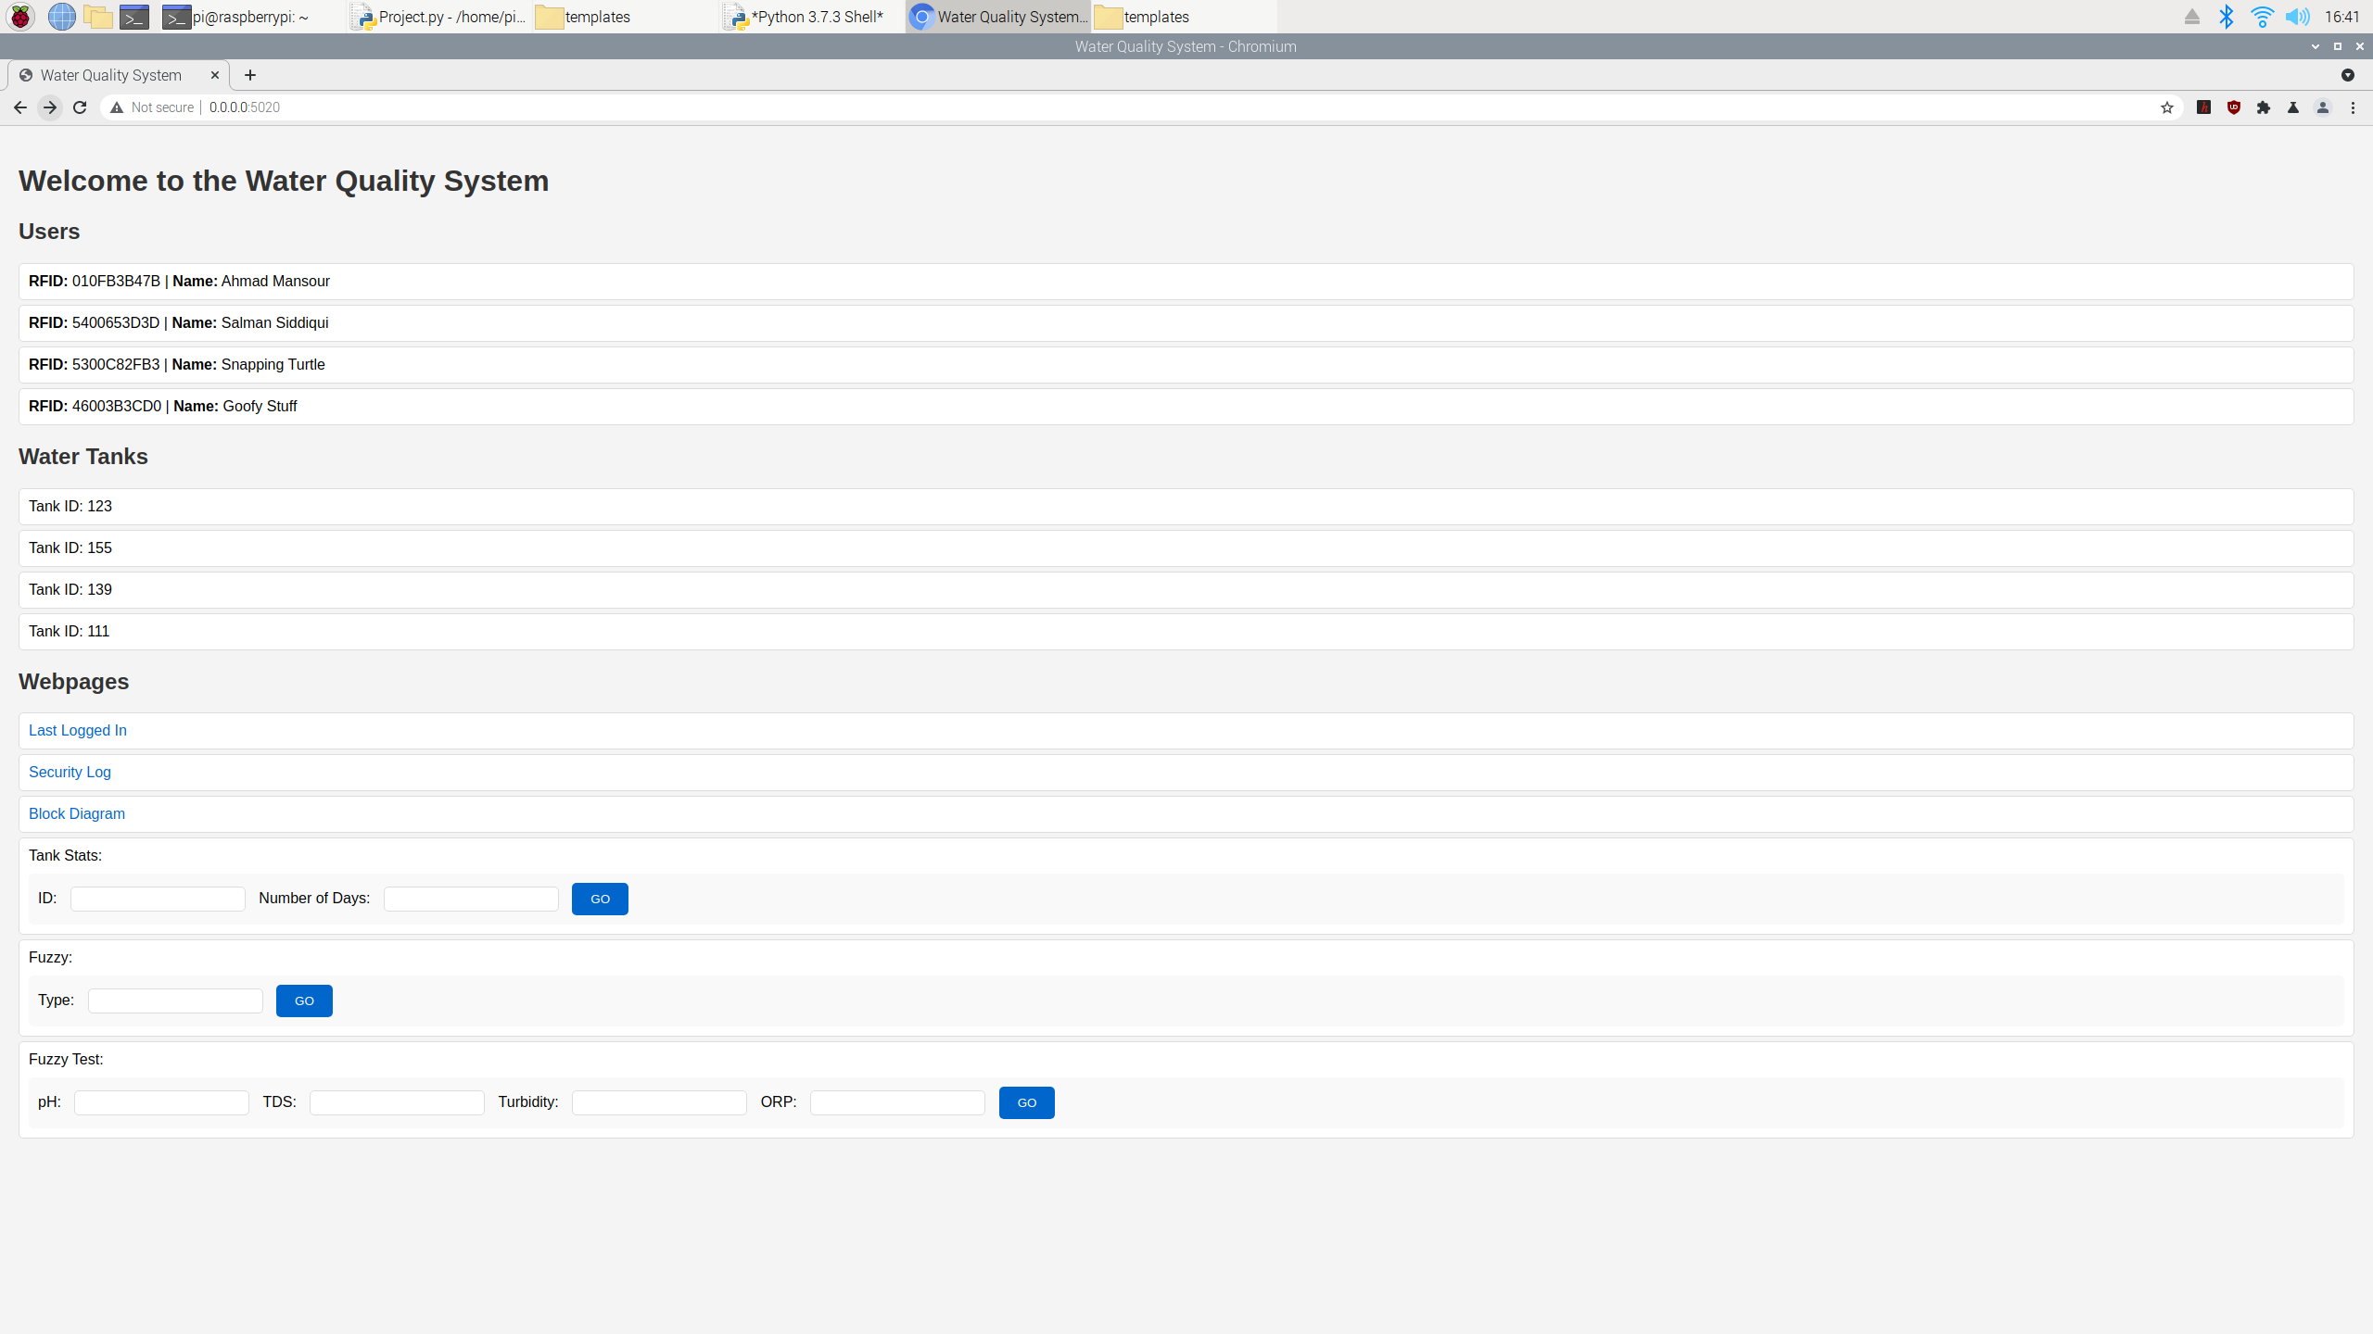

Figure - Flask server (index route)

As described above, the “Last Logged In” option allows you to access the “/lastLoggedIn” static route to see a photo of the last person to login, the “Security Log” option allows you to access the “/securityLog” static route to download the latest video recording of a security breach. The “Block Diagram” option allows you to access the “/blockDiagram” static route which displays an HTML file containing the block diagram presented in Figure 1. For dynamic routes, “Tank Stats” allows the user to access the "/tankStats/<id>/<numOfDays>" dynamic route which lets the user view the history of readings for the specified tank across the specified last number of days (with a maximum of 1000 readings):

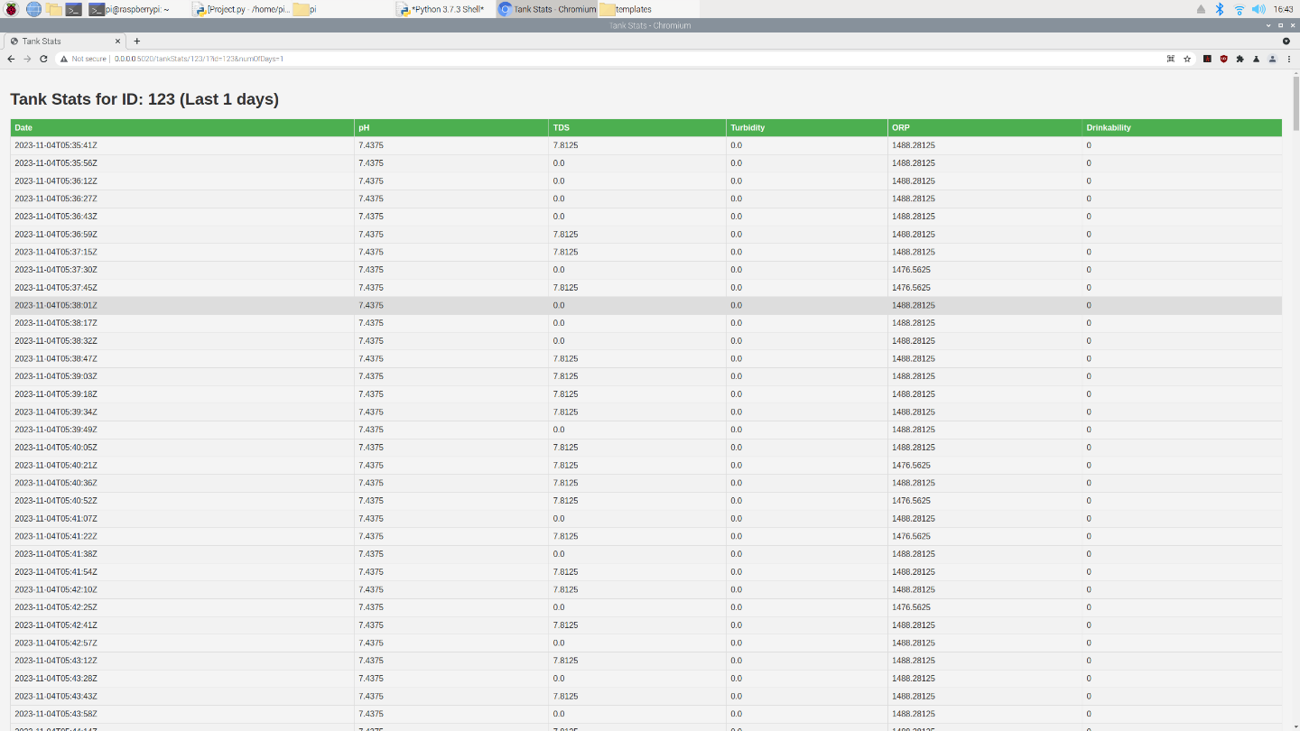

Figure - Flask server (tankStats dynamic route)

The “Fuzzy” option allows the users to access the “/fuzzy/<type>” dynamic route to view the membership functions and graph of the specified fuzzy input/output:

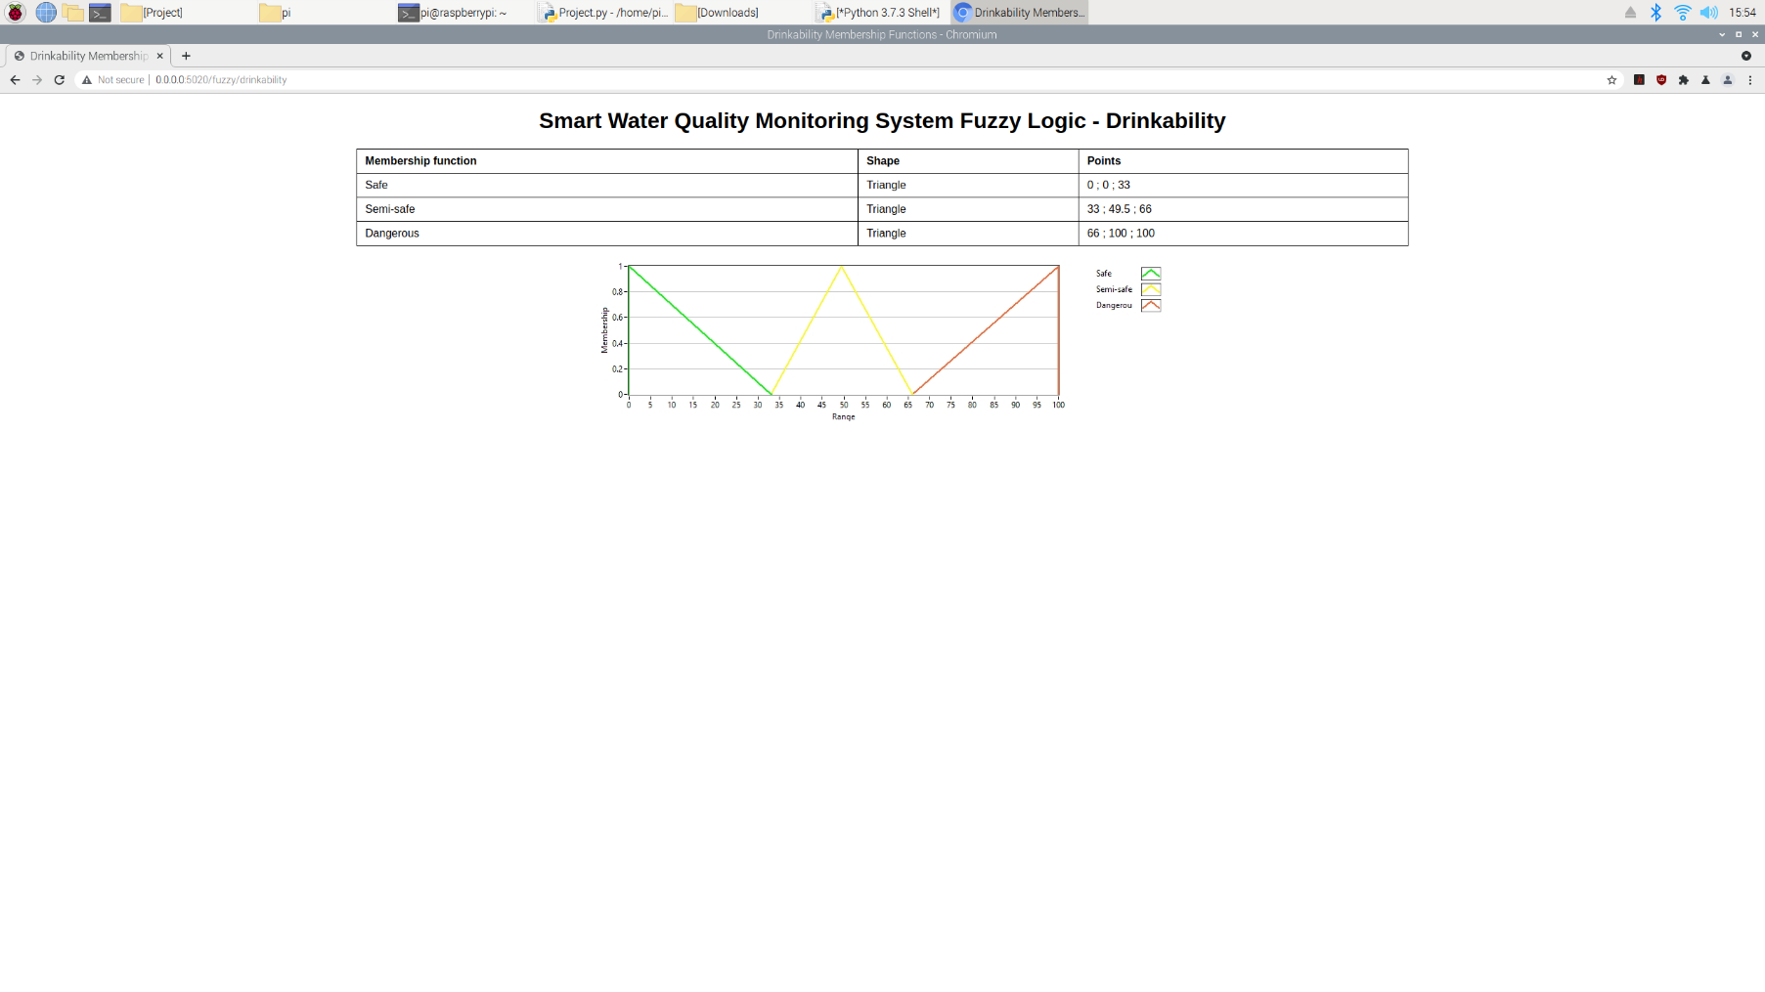

Figure - Flask server (fuzzy dynamic route)

Finally, the “Fuzzy Test” option allows the user to access the "/fuzzyTest/<ph>/<tds>/ <turbidity>/<orp>" dynamic route where the user inputs dummy values to test the functionality of the fuzzy system:

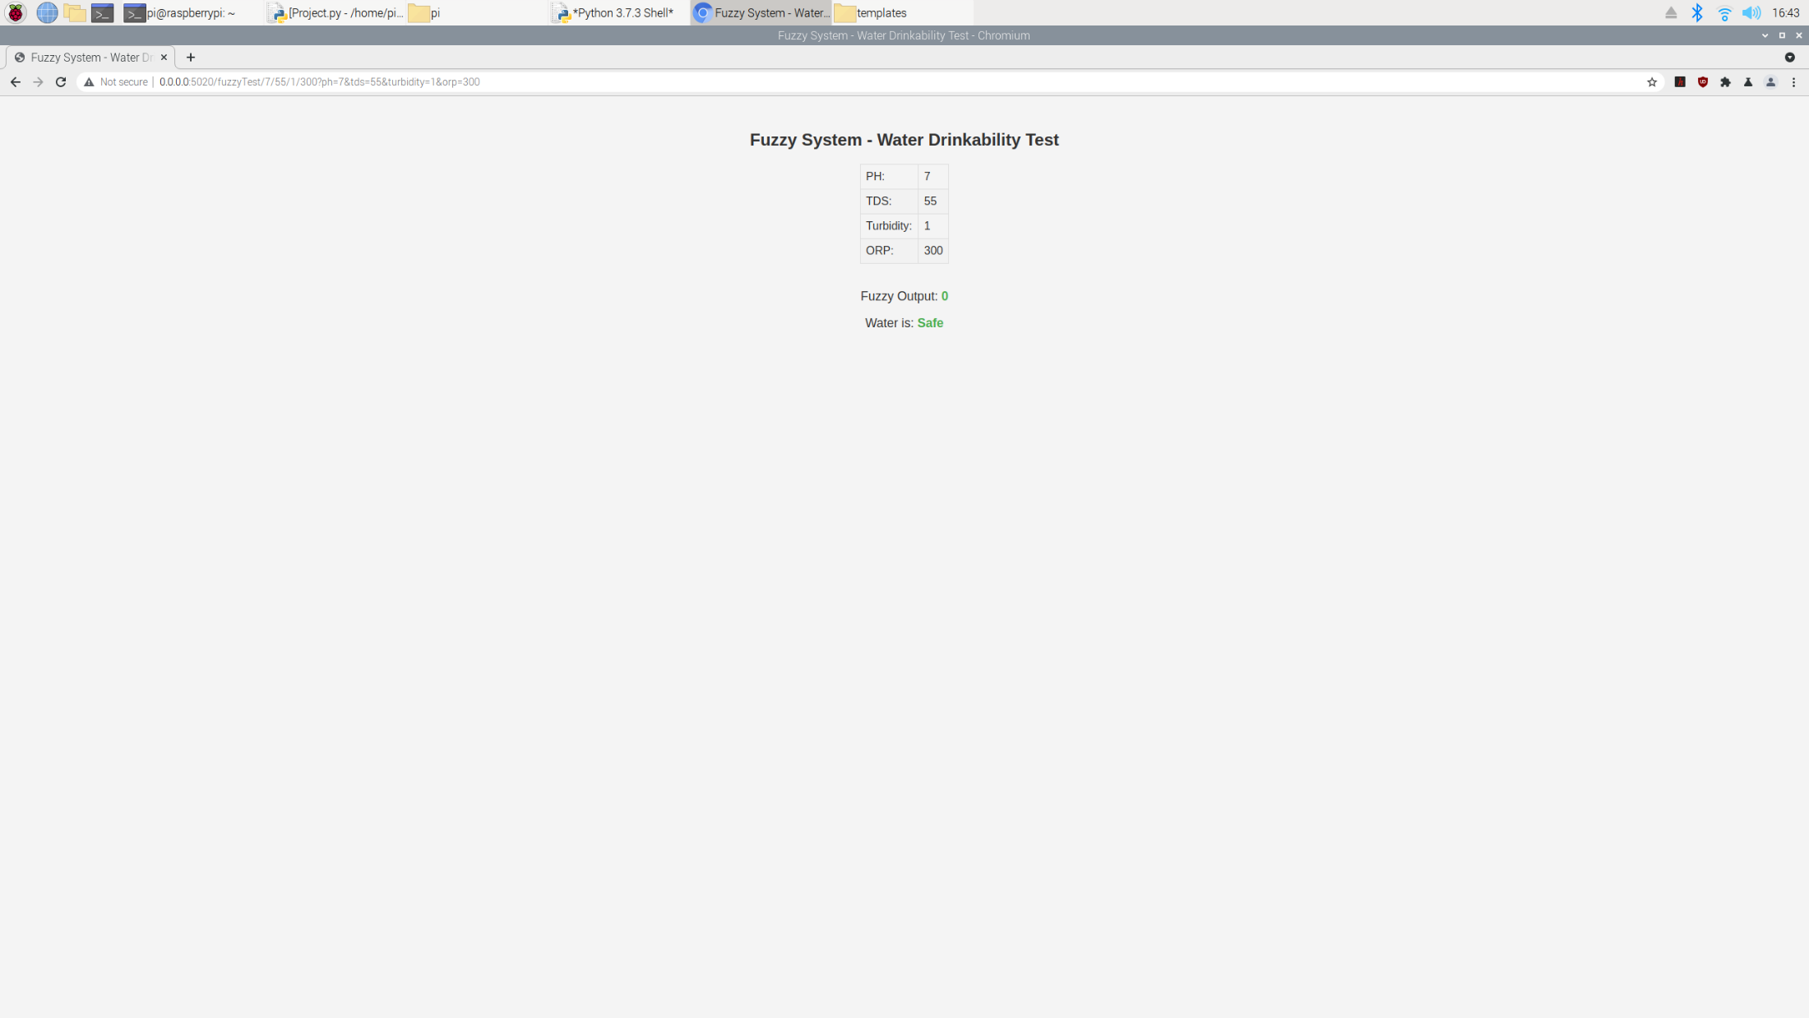

Figure - Flask server (fuzzyTest dynamic route)

Once the user is done with the system, they can type “Q” to turn it off:

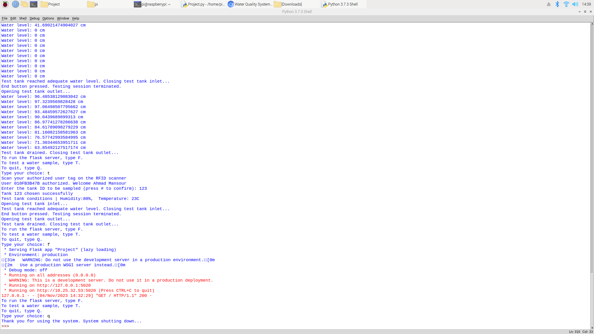

Figure - Turning off system

# Thingspeak screenshots

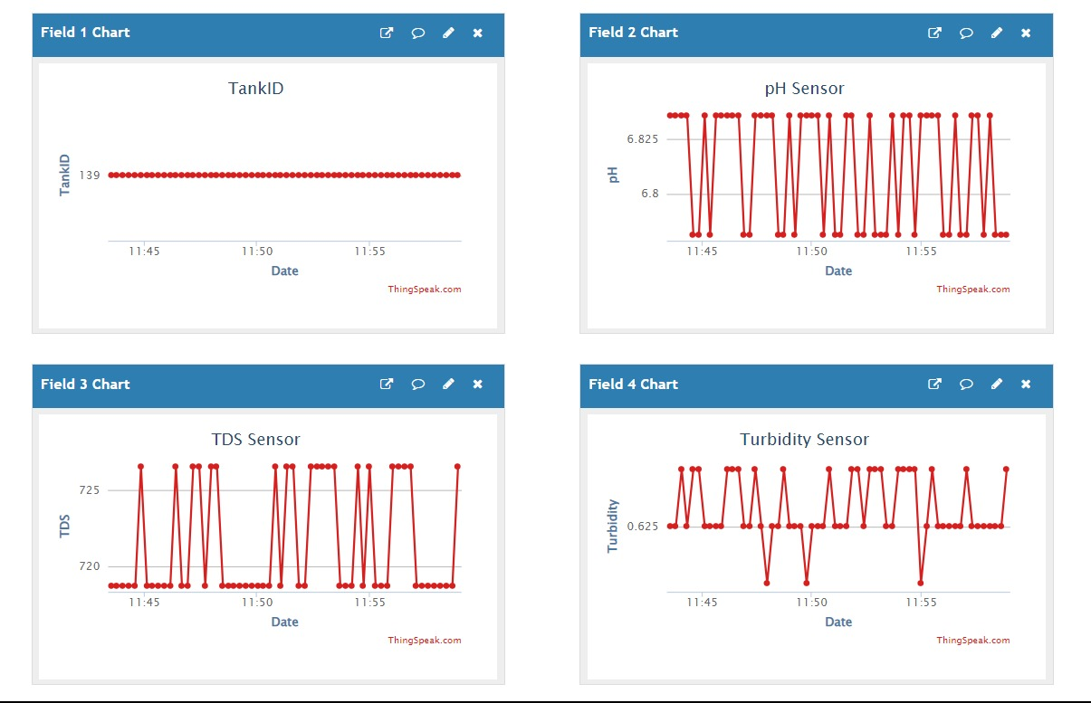

Figure - Thingspeak view 1

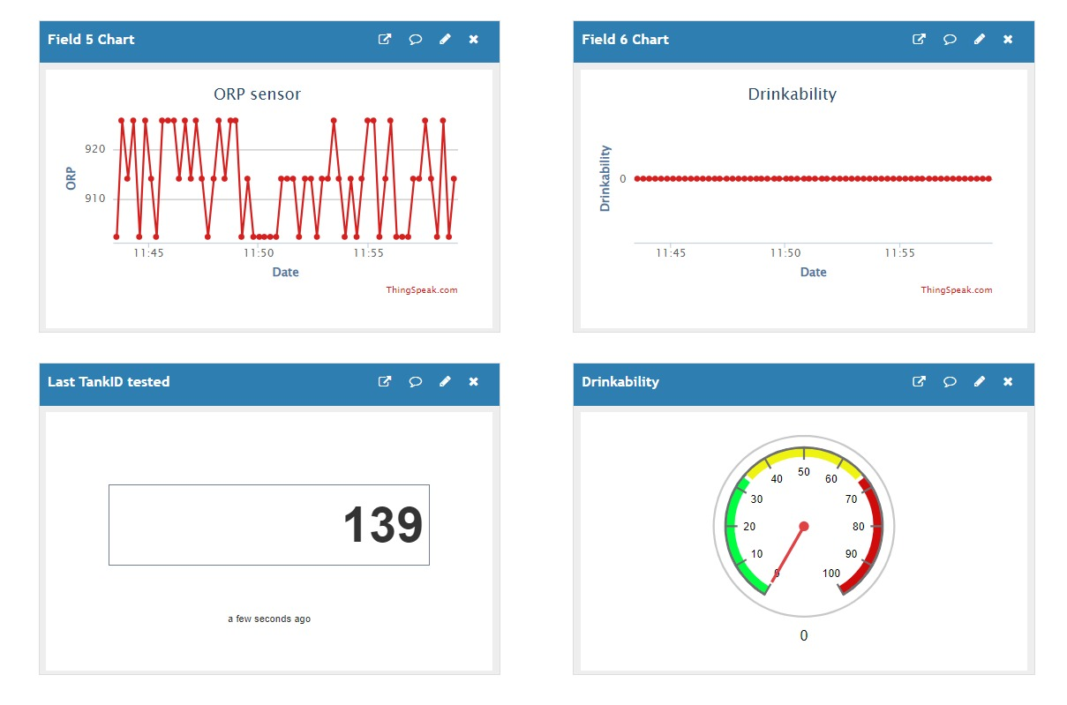

Figure - Thingspeak view 2

# MIT inventor app screenshots

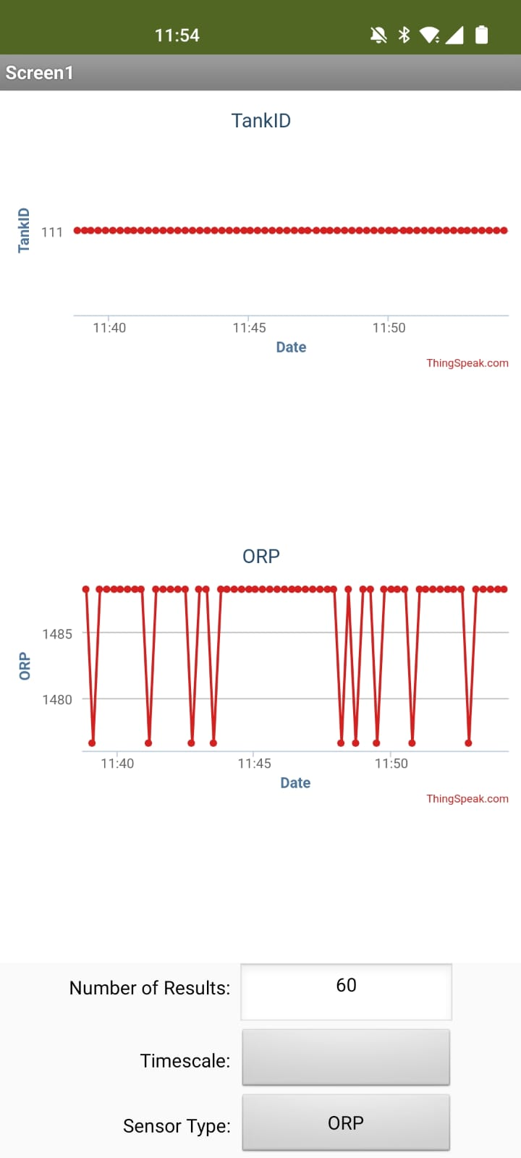

Figure – MIT inventor app view

# Additional features

The following were additional over the base requirements:

* 4 analog inputs rather than 2
* 2 interrupts rather than 1
* 3 static routes rather than 2 (excluding the 5 static routes used to display the fuzzy membership function graphs in the fuzzy dynamic route)
* 3 dynamic routes rather than 2
* 6 variables uploaded to Thingspeak rather than 2
* 6 variables downloaded from Thingspeak rather than 2
* MIT inventor app logic using block coding
* Fuzzy system modeling using LabView
* Use of HTML files to display in Flask routes
* Interactive index route

## MIT inventor app block code

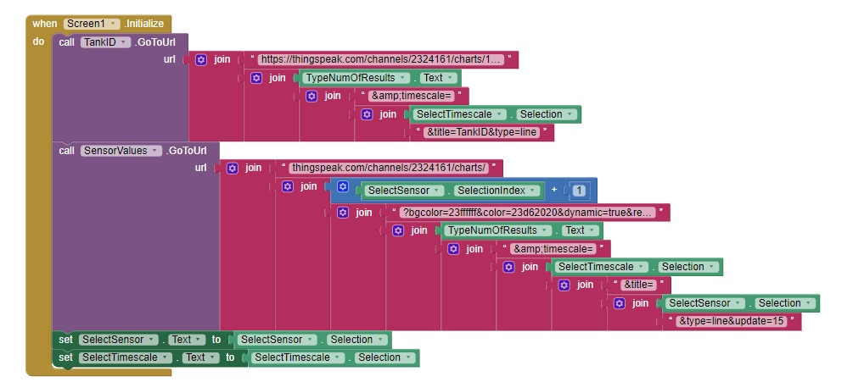

Figure - MIT inventor app block code 1 (Initialization)

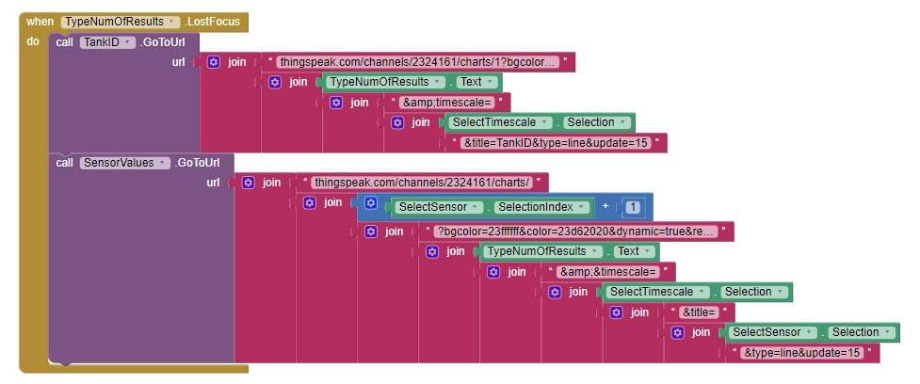

Figure - MIT inventor app block code 2 (Timescale change)

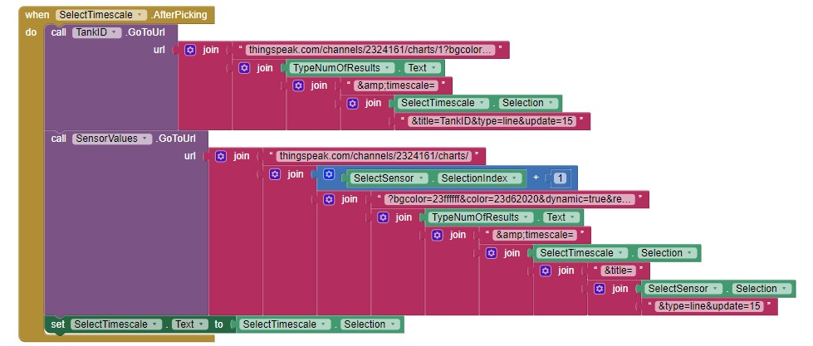

Figure - MIT inventor app block code 3 (Number of results change)

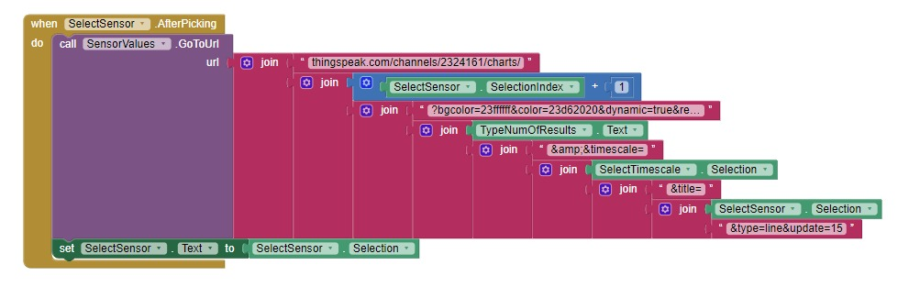

Figure - MIT inventor app block code (Sensor selection change)

## LabView Fuzzy system simulation

* Input variables

|  |  |  |
| --- | --- | --- |
| **Name** | **Range** | **Number of membership functions** |
| PH | 0 -> 14 | 3 |
| TDS | 0 -> 2000 | 3 |
| Turbidity | 0 -> 5 | 2 |
| ORP | -1500 -> 1500 | 2 |

* Output variables

|  |  |  |
| --- | --- | --- |
| **Name** | **Range** | **Number of membership functions** |
| Drinkability | 0 -> 100 | 3 |

* Input membership functions

1. PH

|  |  |  |
| --- | --- | --- |
| **Membership function** | **Shape** | **Points** |
| Acidic | Trapezoid | 0 ; 0 ; 4 ; 6 |
| Neutral | Trapezoid | 5 ; 6 ; 8 ; 9 |
| Basic | Trapezoid | 8 ; 10 ; 14 ; 14 |

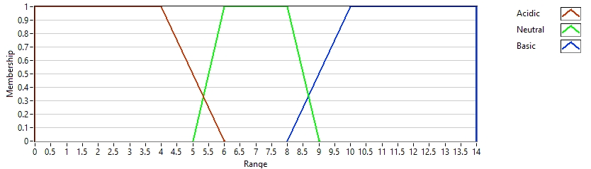

Figure - Fuzzy input 1 membership function graph (pH)

1. TDS

|  |  |  |
| --- | --- | --- |
| **Membership function** | **Shape** | **Points** |
| Stale | Trapezoid | 0 ; 0 ; 50 ; 100 |
| Normal | Trapezoid | 50 ; 75 ; 750 ; 1200 |
| Salty | Trapezoid | 1000 ; 1200 ; 2000 ; 2000 |

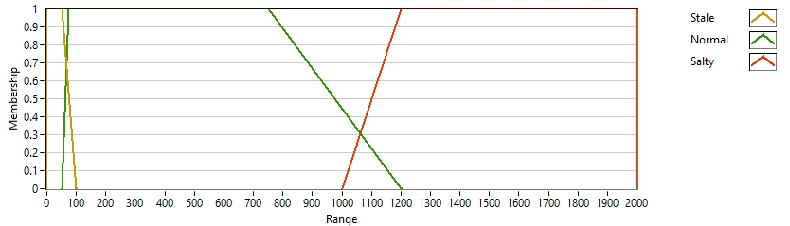

Figure - Fuzzy input 2 membership function graph (TDS)

1. Turbidity

|  |  |  |
| --- | --- | --- |
| **Membership function** | **Shape** | **Points** |
| Clear | Trapezoid | 0 ; 0.3 ; 1 ; 1.5 |
| Cloudy | Trapezoid | 1 ; 1.5 ; 5 ; 5 |
|  |  |  |

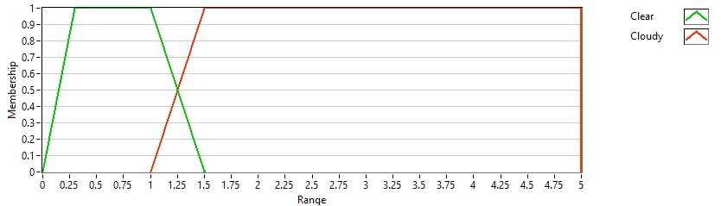

Figure - Fuzzy input 3 membership function graph (Turbidity)

1. ORP

|  |  |  |
| --- | --- | --- |
| **Membership function** | **Shape** | **Points** |
| Unsuitable | Trapezoid | -1500 ; -1500 ; 0 ; 200 |
| Suitable | Trapezoid | 0 ; 200 ; 1500 ; 1500 |
|  |  |  |

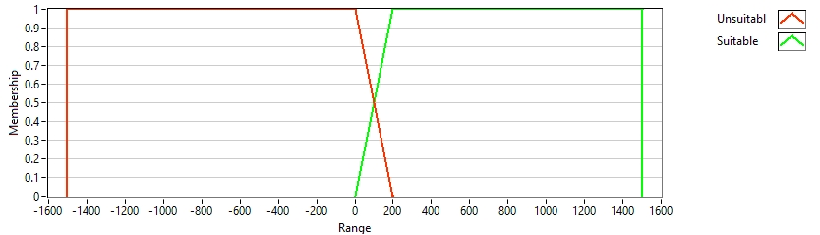

Figure - Fuzzy input 4 membership function graph (ORP)

* Output membership functions

1. Drinkability

|  |  |  |
| --- | --- | --- |
| **Membership function** | **Shape** | **Points** |
| Safe | Triangle | 0 ; 0 ; 33 |
| Semi-safe | Triangle | 33 ; 49.5 ; 66 |
| Dangerous | Triangle | 66 ; 100 ; 100 |

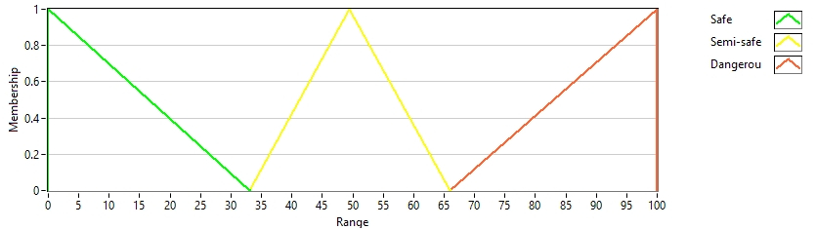

Figure - Fuzzy output 1 membership function graph (Drinkability)

## index.html

<!DOCTYPE html>

<html lang="en">

<head>

<meta charset="UTF-8">

<meta name="viewport" content="width=device-width, initial-scale=1.0">

<title>Water Quality System</title>

<style>

body {

font-family: 'Arial', sans-serif;

background-color: #f4f4f4;

margin: 0;

padding: 20px;

}

h1, h2 {

color: #333;

}

ul {

list-style-type: none;

padding: 0;

}

li {

background-color: #fff;

border: 1px solid #ddd;

padding: 10px;

margin-bottom: 5px;

border-radius: 5px;

}

a {

color: #06c;

text-decoration: none;

}

a:hover {

text-decoration: underline;

}

form {

margin-top: 10px;

}

label {

margin-right: 10px;

}

input[type=text] {

border: 1px solid #ddd;

border-radius: 5px;

padding: 5px;

margin-right: 10px;

}

input[type=submit] {

background-color: #06c;

color: white;

border: none;

padding: 10px 20px;

text-transform: uppercase;

border-radius: 5px;

cursor: pointer;

}

input[type=submit]:hover {

background-color: #0056b3;

}

#tankStatsForm, #fuzzyForm, #fuzzyTestForm {

background-color: #f9f9f9;

padding: 10px;

border-radius: 5px;

}

</style>

</head>

<body>

<h1>Welcome to the Water Quality System</h1>

<h2>Users</h2>

<ul>

{% for rfid, name in validRFIDs %}

<li><strong>RFID:</strong> **{{** rfid **}}** | <strong>Name:</strong> **{{** name **}}**</li>

{% endfor %}

</ul>

<h2>Water Tanks</h2>

<ul>

{% for tank in tankIDs %}

<li>Tank ID: **{{** tank **}}**</li>

{% endfor %}

</ul>

<h2>Webpages</h2>

<ul>

<li><a href="**{{** url_for('lastLogin') **}}**">Last Logged In</a></li>

<li><a href="**{{** url_for('securityLog') **}}**">Security Log</a></li>

<li><a href="**{{** url_for('blockDiagram') **}}**">Block Diagram</a></li>

<li>

Tank Stats:

<form id="tankStatsForm" action="#" method="get">

<label for="id">ID: </label>

<input type="text" id="idInput" name="id" required>

<label for="numOfDays">Number of Days: </label>

<input type="text" id="numOfDaysInput" name="numOfDays" required>

<input type="submit" value="Go">

</form>

</li>

<li>

Fuzzy:

<form id="fuzzyForm" action="#" method="get">

<label for="type">Type: </label>

<input type="text" id="typeInput" name="type" required>

<input type="submit" value="Go">

</form>

</li>

<li>

Fuzzy Test:

<form id="fuzzyTestForm" action="#" method="get">

<label for="ph">pH: </label>

<input type="text" id="phInput" name="ph" required>

<label for="tds">TDS: </label>

<input type="text" id="tdsInput" name="tds" required>

<label for="turbidity">Turbidity: </label>

<input type="text" id="turbidityInput" name="turbidity" required>

<label for="orp">ORP: </label>

<input type="text" id="orpInput" name="orp" required>

<input type="submit" value="Go">

</form>

</li>

</ul>

<script>

document.getElementById('tankStatsForm').onsubmit = function() {

const id = document.getElementById('idInput').value;

const numOfDays = document.getElementById('numOfDaysInput').value;

this.action = `/tankStats/${id}/${numOfDays}`;

}

document.getElementById('fuzzyForm').onsubmit = function() {

const type = document.getElementById('typeInput').value;

this.action = `/fuzzy/${type}`;

}

document.getElementById('fuzzyTestForm').onsubmit = function() {

const ph = document.getElementById('phInput').value;

const tds = document.getElementById('tdsInput').value;

const turbidity = document.getElementById('turbidityInput').value;

const orp = document.getElementById('orpInput').value;

this.action = `/fuzzyTest/${ph}/${tds}/${turbidity}/${orp}`;

}

</script>

</body>

</html>

## ph.html

<!DOCTYPE html>

<html>

<head>

<meta charset="utf-8">

<title>PH Membership Functions</title>

<style>

body {

font-family: Arial;

}

table {

border-collapse: collapse;

margin: 20px auto;

width: 60%;

}

th, td {

border: 1px solid black;

padding: 8px 12px;

}

img {

display: block;

margin: 20px auto;

}

</style>

</head>

<body>

<center>

<h1>Smart Water Quality Monitoring System Fuzzy Logic - PH</h1>

<table>

<thead>

<tr>

<th align="left">Membership function</th>

<th align="left">Shape</th>

<th align="left">Points</th>

</tr>

</thead>

<tbody>

<tr>

<td>Acidic</td>

<td>Trapezoid</td>

<td>0 ; 0 ; 4 ; 6</td>

</tr>

<tr>

<td>Neutral</td>

<td>Trapezoid</td>

<td>5 ; 6 ; 8 ; 9</td>

</tr>

<tr>

<td>Basic</td>

<td>Trapezoid</td>

<td>8 ; 10 ; 14 ; 14</td>

</tr>

</tbody>

</table>

<img src="/ph" alt="PH Graph">

</center>

</body> </html>

## turbidity.html

<!DOCTYPE html>

<html>

<head>

<meta charset="utf-8">

<title>Turbidity Membership Functions</title>

<style>

body {

font-family: Arial;

}

table {

border-collapse: collapse;

margin: 20px auto;

width: 60%;

}

th, td {

border: 1px solid black;

padding: 8px 12px;

}

img {

display: block;

margin: 20px auto;

}

</style>

</head>

<body>

<center>

<h1>Smart Water Quality Monitoring System Fuzzy Logic - Turbidity</h1>

<table>

<thead>

<tr>

<th align="left">Membership function</th>

<th align="left">Shape</th>

<th align="left">Points</th>

</tr>

</thead>

<tbody>

<tr>

<td>Clear</td>

<td>Trapezoid</td>

<td>0 ; 0.3 ; 1 ; 1.5</td>

</tr>

<tr>

<td>Cloudy</td>

<td>Trapezoid</td>

<td>1 ; 1.5 ; 5 ; 5</td>

</tr>

</tbody>

</table>

<img src="/turbidity" alt="Turbidity Graph">

</center>

</body>

</html>

## tds.html

<!DOCTYPE html>

<html>

<head>

<meta charset="utf-8">

<title>TDS Membership Functions</title>

<style>

body {

font-family: Arial;

}

table {

border-collapse: collapse;

margin: 20px auto;

width: 60%;

}

th, td {

border: 1px solid black;

padding: 8px 12px;

}

img {

display: block;

margin: 20px auto;

}

</style>

</head>

<body>

<center>

<h1>Smart Water Quality Monitoring System Fuzzy Logic - TDS</h1>

<table>

<thead>

<tr>

<th align="left">Membership function</th>

<th align="left">Shape</th>

<th align="left">Points</th>

</tr>

</thead>

<tbody>

<tr>

<td>Stale</td>

<td>Trapezoid</td>

<td>0 ; 0 ; 50 ; 100</td>

</tr>

<tr>

<td>Normal</td>

<td>Trapezoid</td>

<td>50 ; 75 ; 750 ; 1200</td>

</tr>

<tr>

<td>Salty</td>

<td>Trapezoid</td>

<td>1000 ; 1200 ; 2000 ; 2000</td>

</tr>

</tbody>

</table>

<img src="/tds" alt="TDS Graph">

</center>

</body> </html>

## orp.html

<!DOCTYPE html>

<html>

<head>

<meta charset="utf-8">

<title>ORP Membership Functions</title>

<style>

body {

font-family: Arial;

}

table {

border-collapse: collapse;

margin: 20px auto;

width: 60%;

}

th, td {

border: 1px solid black;

padding: 8px 12px;

}

img {

display: block;

margin: 20px auto;

max-width: 80%;

}

</style>

</head>

<body>

<center>

<h1>Smart Water Quality Monitoring System Fuzzy Logic - ORP</h1>

<table>

<thead>

<tr>

<th align="left">Membership function</th>

<th align="left">Shape</th>

<th align="left">Points</th>

</tr>

</thead>

<tbody>

<tr>

<td>Unsuitable</td>

<td>Trapezoid</td>

<td>-1500 ; -1500 ; 0 ; 200</td>

</tr>

<tr>

<td>Suitable</td>

<td>Trapezoid</td>

<td>0 ; 200 ; 1500 ; 1500</td>

</tr>

</tbody>

</table>

<img src="/orp" alt="ORP Graph">

</center>

</body>

</html>

## drinkability.html

<!DOCTYPE html>

<html>

<head>

<meta charset="utf-8">

<title>Drinkability Membership Functions</title>

<style>

body {

font-family: Arial;

}

table {

border-collapse: collapse;

margin: 20px auto;

width: 60%;

}

th, td {

border: 1px solid black;

padding: 8px 12px;

}

img {

display: block;

margin: 20px auto;

}

</style>

</head>

<body>

<center>

<h1>Smart Water Quality Monitoring System Fuzzy Logic - Drinkability</h1>

<table>

<thead>

<tr>

<th align="left">Membership function</th>

<th align="left">Shape</th>

<th align="left">Points</th>

</tr>

</thead>

<tbody>

<tr>

<td>Safe</td>

<td>Triangle</td>

<td>0 ; 0 ; 33</td>

</tr>

<tr>

<td>Semi-safe</td>

<td>Triangle</td>

<td>33 ; 49.5 ; 66</td>

</tr>

<tr>

<td>Dangerous</td>

<td>Triangle</td>

<td>66 ; 100 ; 100</td>

</tr>

</tbody>

</table>

<img src="/drinkability" alt="Drinkability Graph">

</center>

</body> </html>

## tank_stats.html

<!DOCTYPE html>

<html lang="en">

<head>

<meta charset="UTF-8">

<meta name="viewport" content="width=device-width, initial-scale=1.0">

<title>Tank Stats</title>

<style>

body {

font-family: 'Arial', sans-serif;

background-color: #f4f4f4;

margin: 0;

padding: 20px;

color: #333;

}

h1 {

color: #333;

margin-bottom: 20px;

}

table {

width: 100%;

border-collapse: collapse;

margin-bottom: 20px;

}

table, th, td {

border: 1px solid #ddd;

}

th, td {

text-align: left;

padding: 8px;

}

th {

background-color: #4CAF50;

color: white;

}

tr:nth-child(even) {

background-color: #f2f2f2;

}

tr:hover {

background-color: #ddd;

}

</style>

</head>

<body>

<h1>Tank Stats for ID: **{{** id **}}** (Last **{{** numOfDays **}}** days)</h1>

<table>

<thead>

<tr>

<th>Date</th>

<th>pH</th>

<th>TDS</th>

<th>Turbidity</th>

<th>ORP</th>

<th>Drinkability</th>

</tr>

</thead>

<tbody>

<!-- Sample template data, replace with server-side template logic -->

{% for entry in data %}

<tr>

<td>**{{** entry.created_at **}}**</td>

<td>**{{** entry.field2 **}}**</td>

<td>**{{** entry.field3 **}}**</td>

<td>**{{** entry.field4 **}}**</td>

<td>**{{** entry.field5 **}}**</td>

<td>**{{** entry.field6 **}}**</td>

</tr>

{% endfor %}

</tbody>

</table>

</body>

</html>

## fuzzy_test_result.html

<!DOCTYPE html>

<html>

<head>

<title>Fuzzy System - Water Drinkability Test</title>

<style>

body {

font-family: 'Arial', sans-serif;

background-color: #f4f4f4;

color: #333;

text-align: center;

padding: 20px;

}

h2 {

color: #333;

margin-bottom: 20px;

}

table {

margin-left: auto;

margin-right: auto;

border-collapse: collapse;

width: auto;

}

td {

border: 1px solid #ddd;

padding: 8px;

text-align: left;

}

tr:nth-child(even) {

background-color: #f2f2f2;

}

p {

font-size: 1.1em;

}

strong {

color: #4CAF50;

}

</style>

</head>

<body>

<h2>Fuzzy System - Water Drinkability Test</h2>

<table>

<tr>

<td>PH:</td>

<td>**{{** ph **}}**</td>

</tr>

<tr>

<td>TDS:</td>

<td>**{{** tds **}}**</td>

</tr>

<tr>

<td>Turbidity:</td>

<td>**{{** turbidity **}}**</td>

</tr>

<tr>

<td>ORP:</td>

<td>**{{** orp **}}**</td>

</tr>

</table>

<br>

<p>Fuzzy Output: <strong>**{{** fuzzy_output **}}**</strong></p>

<p>Water is: <strong>**{{** drinkability **}}**</strong></p>

</body>

</html>